

*ONLINE PET SHOP*

**Faculty: Ho Hoan Kiem**

**Batch:**

**Team Member:**

**Hoàng Tuấn Anh**

**Ho Chi Minh City, Oct 10 2019**

Table of Contents

1. **Review 1**

* **Problem Definition 04**
* **Customer Request Specification 05**

1. **Review 2**

* ***Use Case Diagram* 04**
* ***Class Diagram* 15**
* ***Sequence Diagram* 16**
* ***ERD* 18**
* ***Entity Description* 19**
* ***Table Relationship Diagram* 26**

1. **Review 3**

* **Interface Design 27**
* **Site Map 51**
* **Report 53**
* **Tasks Sheet 56**

**REVIEW 1**

Problem Definition

1. **The Object Of The Project**

This project will aim at the creation of an E-Commerce website dealing with pet’s accessories. This will be accessible to all customers whether they have accounts or not. Users with “admin” role will be able to manage pet’s accessories, categories, users’ transactions. Users with “user” role will be able to manage their information, order products, view their favorite list of pet’s accessories and show their order history. Users with or without an account will be able to view products’ information. This system provides the following facilities:

* Manage pet’s accessories information (create, update, retrieve)
* Manage categories’ information (create, update, delete, retrieve)
* Manage users’ transactions (update, retrieve)
* Search and filter by different accessories criteria: category, name.
* Order accessories.
* Show order history.
* Make a favorite list of accessories

Customer Request Specification

1. **Functional Requirements**

Following is a list of functionality of the system.

## Accessories:

* Add accessories
* Edit attributes of accessories
* Delete/Restore accessories
* Add accessories’ images
* Search to easily find accessories in certain categories or with specific attributes
* Make a favorite list of accessories

## Users:

* Register
* Login
* Logout
* Manage account details (address, phone number,...)
* View user details

## Category management:

* Create category
* Edit category
* Feature categories within navigation, on Home Page, on Admin Accessories Page or on search filter

## Transaction management:

* Add accessories to cart
* View cart and update quantity of accessories in cart.
* Checkout cart
* Update order status (by admin)
* Show order history list.

# 2. Hardware/ Software Requirements

By adding new technologies such as ASP.NET Core 3.0 SDK, AJAX, cloud services (Azure SQL database server) and MVC architecture, the web site becomes more interactive with users and easily updated.

1. **System Requirement**

* **For Users**
  + **Hardware**
    - CPU: Intel Core i5 2.3 GHz or higher
    - RAM: 1GB MB or higher
  + **Software**
    - OS: Windows 7/10…
    - Browser: Internet Explorer 8.0 or higher
* **For Software Developers**
  + **Hardware**
    - CPU: Intel Core i5 2.3 GHz or higher
    - RAM: 1GB MB or higher
  + **Software**
    - OS: Windows 10
    - Database server: Azure SQL server
    - IDE: Microsoft Visual Studio 2019
    - Web Server: Internet Information Services (IIS), Kestrel

**REVIEW 2**

**USE CASE DIAGRAM**

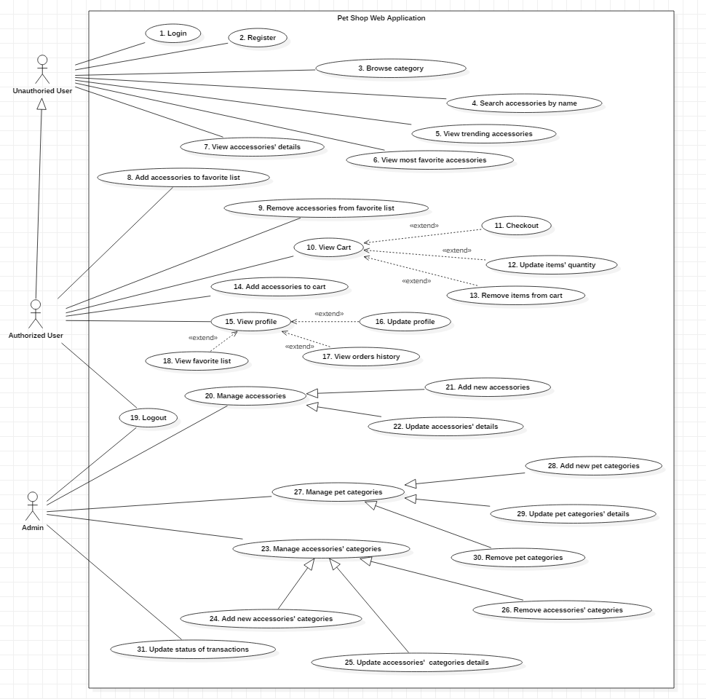

**USE CASE DESCRIPTION**

1. **Actor:**

* **Unauthorized User:** include visitors who doesn’t register.
* **Authorized User:** include visitors who has registered.
* **Administrators :** The person(s) that manage and maintain this web site.

1. **Use Case Specification:**

**Use Case Specification**

|  |  |  |  |
| --- | --- | --- | --- |
| UC ID and Name: | **UC-1 Login** | | |
| Created By: | AnhHT | Date Created: | 11/10/2019 |
| Primary Actor: | Unauthorized User | Secondary Actors: | Web server |
| Trigger: | An unauthorized user indicates that he/she wants to login | | |
| Description: | An unauthorized user uses their username and password to login | | |
| Preconditions: | PRE-1: Unauthorized user has been registered in the system | | |
| Postconditions: | POST-1: Unauthorized user becomes authorized user | | |
| Normal Flow: | **1.0 Login by using website’s login system**  1. Unauthorized user accesses any page  2. Web server responses the page which Unauthorized user accesses.  3. Unauthorized user choose Login link on header  4. A popup modal is showed login form  5. Unauthorized user inputs their username and password in each text field and send request to Web server  6. Web server checks username and password, then responses home page, unauthorized user becomes authorized user | | |
| Alternative Flows: | **1.1 Login when unauthorized user needs to view cart**  1. Unauthorized user choose Shopping Cart link (on header or footer) and send request  2. Return step 4 in normal flow  **1.2 Login when unauthorized user needs to add accessories to cart**  1. Unauthorized user adds their accessories to cart and send request  2. Return step 4 in normal flow  **1.1 Login when unauthorized user needs to add accessories to favorite list**  1. Unauthorized user adds their accessories to favorite list and send request  2. Return step 4 in normal flow | | |
| Exceptions: | **1.0E1 Wrong username or password**  1. Return step 5 in normal flow with announcement: “Username or password incorrect” | | |
| Priority: | High | | |

|  |  |  |  |
| --- | --- | --- | --- |
| UC ID and Name: | **UC-2 Register** | | |
| Created By: | AnhHT | Date Created: | 11/10/2019 |
| Primary Actor: | Unauthorized User | Secondary Actors: | Web server |
| Trigger: | An unauthorized user indicates that he/she wants to register | | |
| Description: | An unauthorized user give their information to create an account in the website’s system | | |
| Preconditions: |  | | |
| Postconditions: | POST-1: Unauthorized user becomes authorized user | | |
| Normal Flow: | **1.0 Register by using website’s register system**  1. Unauthorized user accesses any page  2. Web server responses the page which Unauthorized user accesses.  3. Unauthorized user choose Sign Up link on header.  4. A popup modal is showed with register form.  5. Unauthorized user inputs their information in each text field and send request to Web server  6. Web server stores unauthorized user’s information then responses home page, unauthorized user becomes authorized user | | |
| Alternative Flows: |  | | |
| Exceptions: | **1.0E1 Invalid username**  1a. Return step 5 in normal flow with announcement: “Username is already existed. Please input another username.” | | |
| Priority: | High | | |

|  |  |  |  |
| --- | --- | --- | --- |
| UC ID and Name: | **UC-3 Browse category** | | |
| Created By: | AnhHT | Date Created: | 11/10/2019 |
| Primary Actor: | Unauthorized User | Secondary Actors: | Web server |
| Trigger: | An unauthorized user indicates that he/she wants to view accessories based on their desired category | | |
| Description: | An unauthorized user views and chooses their desired category | | |
| Preconditions: |  | | |
| Postconditions: | POST-1: Web server responses a list of accessories in unauthorized user’s desired category  POST-2: Browser shows the list of accessories to unauthorized user | | |
| Normal Flow: | **1.0 Choose category on the navigation bar**  1. Unauthorized user hovers the “Accessories” button on the menu bar  2. Browser shows all the list of available categories  3. Unauthorized user chooses their desired category  4. Web server responses the category page with the list of accessories | | |
| Alternative Flows: | **1.1 Choose category on the navigation bar**  1. Unauthorized user clicks the “Accessories” button on the menu bar  4. Web server responses the page with the list of all accessories | | |
| Exceptions: | **1.0E1 Lost Internet Connection**  1. Return current step in normal flow with announcement: “Load Accessories error” | | |
| Priority: | High | | |

|  |  |  |  |
| --- | --- | --- | --- |
| UC ID and Name: | **UC-4 Search accessories by name** | | |
| Created By: | AnhHT | Date Created: | 11/10/2019 |
| Primary Actor: | Unauthorized User | Secondary Actors: | Web server |
| Trigger: | An unauthorized user indicates that he/she wants to see the list of accessories in their desired name | | |
| Description: | An unauthorized user input their accessories’ desired name | | |
| Preconditions: |  | | |
| Postconditions: | POST-1: Web server responses the list of accessories based on unauthorized user’s desired name | | |
| Normal Flow: | **1.0 Input name**  1. Unauthorized user input their desired name in Search bar on header  2. Unauthorized user clicks Search icon button  3. Web server responses the list of accessories related to that name and browser shows it. | | |
| Alternative Flows: |  | | |
| Exceptions: |  | | |
| Priority: | Medium | | |

|  |  |  |  |
| --- | --- | --- | --- |
| UC ID and Name: | **UC-5 View trending accessories** | | |
| Created By: | AnhHT | Date Created: | 11/10/2019 |
| Primary Actor: | Unauthorized User | Secondary Actors: | Web server |
| Trigger: | An unauthorized user indicates that he/she wants to see new and trending accessories | | |
| Description: | An unauthorized user view trending accessories | | |
| Preconditions: | PRE-1: Internet connection | | |
| Postconditions: | POST-1: Web server response the home page with news and top 8 latest accessories | | |
| Normal Flow: | **1.0 Access home page**  1. Unauthorized user access home page by using url bar  2. Web server response the home page with trends | | |
| Alternative Flows: | **1.1 Click on “Home” button**  1. Unauthorized user clicks the “Home” button on the navigation bar, logo or header  2. Return to step 2 in normal flow | | |
| Exceptions: |  | | |
| Priority: | Low | | |

|  |  |  |  |
| --- | --- | --- | --- |
| UC ID and Name: | **UC-6 View most favorite accessories** | | |
| Created By: | AnhHT | Date Created: | 11/10/2019 |
| Primary Actor: | Unauthorized User | Secondary Actors: | Web server |
| Trigger: | An unauthorized user indicates that he/she wants to see most favorite accessories | | |
| Description: | An unauthorized user view most favorite accessories | | |
| Preconditions: | PRE-1: Internet connection | | |
| Postconditions: | POST-1: Web server response the home page with news and top 8 most favorite accessories | | |
| Normal Flow: | **1.0 Access home page**  1. Unauthorized user access home page by using url bar  2. Web server response the home page with trends | | |
| Alternative Flows: | **1.1 Click on “Home” button**  1. Unauthorized user clicks the “Home” button on the navigation bar, logo or header  2. Return to step 2 in normal flow | | |
| Exceptions: |  | | |
| Priority: | Low | | |

|  |  |  |  |
| --- | --- | --- | --- |
| UC ID and Name: | **UC-7 View accessories’ detail** | | |
| Created By: | AnhHT | Date Created: | 11/10/2019 |
| Primary Actor: | Unauthorized User | Secondary Actors: | Web server |
| Trigger: | An unauthorized user indicates that he/she wants to view the desired accessories’ details | | |
| Description: | An unauthorized user chooses and view their desired accessory by clicking on that accessory | | |
| Preconditions: |  | | |
| Postconditions: | POST-1: Web server response unauthorized user’s accessory’s details | | |
| Normal Flow: | **1.0 Choose that accessory**  1. Unauthorized user click on the name of desired accessory  2. Web server response the product page with unauthorized user’s desired accessory’s details | | |
| Alternative Flows: |  | | |
| Exceptions: |  | | |
| Priority: | Medium | | |
| Business Rules: |  | | |
| Other Information: |  | | |
| Assumptions: |  | | |

|  |  |  |  |
| --- | --- | --- | --- |
| UC ID and Name: | **UC-8 Add accessories to favorite list** | | |
| Created By: | AnhHT | Date Created: | 11/10/2019 |
| Primary Actor: | Authorized User | Secondary Actors: | Web server |
| Trigger: | An authorized user indicates that he/she wants to add an accessory to his/her favorite list | | |
| Description: | An authorized user adds an accessory to his/her favorite list | | |
| Preconditions: |  | | |
| Postconditions: | POST-1: Web server adds an accessory to user’s favorite list | | |
| Normal Flow: | **1.0 Authorized User clicks “Favorite” button on their desired accessory**  1. Authorized user clicks “Favorite” button on their desired accessory (if the button is white)  2. Web server check, add to favorite list | | |
| Alternative Flows: |  | | |
| Exceptions: | **1.0E1 “Favorite” button is pink**  1. Web Server check, remove accessory from favorite list | | |
| Priority: | Low | | |

|  |  |  |  |
| --- | --- | --- | --- |
| UC ID and Name: | **UC-9 Remove accessories to favorite list** | | |
| Created By: | AnhHT | Date Created: | 11/10/2019 |
| Primary Actor: | Authorized User | Secondary Actors: | Web server |
| Trigger: | An authorized user indicates that he/she wants to remove an accessory from his/her favorite list | | |
| Description: | An authorized user removes an accessory from his/her favorite list | | |
| Preconditions: |  | | |
| Postconditions: | POST-1: Web server removes an accessory from user’s favorite list | | |
| Normal Flow: | **1.0 Authorized User clicks “Favorite” button on their desired accessory**  1. Authorized user clicks “Favorite” button on their desired accessory (if the button is pink)  2. Web server check, remove from favorite list | | |
| Alternative Flows: |  | | |
| Exceptions: | **1.0E1 “Favorite” button is white**  1. Web Server check, add accessory to favorite list | | |
| Priority: | Low | | |

|  |  |  |  |
| --- | --- | --- | --- |
| UC ID and Name: | **UC-10 View cart** | | |
| Created By: | AnhHT | Date Created: | 11/10/2019 |
| Primary Actor: | Authorized User | Secondary Actors: | Web server |
| Trigger: | An unauthorized user indicates that he/she wants to see his/her shopping cart | | |
| Description: | An unauthorized user views his/her shopping cart | | |
| Preconditions: |  | | |
| Postconditions: | POST-1: Web server response authorized user’s shopping cart  POST-2: Browser view the shopping cart for unauthorized user | | |
| Normal Flow: | **1.0 Choose cart icon on header**  1. Authorized user click the cart-icon’s button on the header  2. Web server response the cart page with authorized user’s shopping cart | | |
| Alternative Flows: | **1.1 Choose cart link in footer**  1. Authorized user Cart link on footer  2. Return step 2 in normal flow | | |
| Exceptions: |  | | |
| Priority: | Medium | | |

|  |  |  |  |
| --- | --- | --- | --- |
| UC ID and Name: | **UC-11 Checkout** | | |
| Created By: | AnhHT | Date Created: | 11/10/2019 |
| Primary Actor: | Authorized User | Secondary Actors: | Web server |
| Trigger: | An authorized user indicates that he/she wants to make a purchase | | |
| Description: | An authorized user buys accessories in the shopping cart and make a purchase | | |
| Preconditions: | PRE-1: Current page is cart page | | |
| Postconditions: | POST-1: Web server response confirmation page with successful purchase announcement  POST-2: Browser view the announcement and bill confirmation | | |
| Normal Flow: | **1.0 Purchase order**  1. Authorized user click on the “Proceed to checkout” button  2. Web server check valid every item’s quantity and response authorized user’s order (checkout page) and browser view it  3. Authorized user click on “Checkout” button  4. Web server check again and store order to database with status (Waiting for response)  5. Browser show the order history | | |
| Alternative Flows: |  | | |
| Exceptions: | **1.0E1 Invalid product quantity**  1. Web server response cart page  2. Return step 1 in normal flow | | |
| Priority: | Medium | | |

|  |  |  |  |
| --- | --- | --- | --- |
| UC ID and Name: | **UC-12 Update items' quantity** | | |
| Created By: | AnhHT | Date Created: | 11/10/2019 |
| Primary Actor: | Authorized User | Secondary Actors: | Web server |
| Trigger: | An authorized user indicates that he/she wants to edit his/her shopping cart | | |
| Description: | An authorized user edits his/her shopping cart | | |
| Preconditions: | PRE-1: Current page is cart page | | |
| Postconditions: | POST-1: Browser view the accessory’s updated cart for authorized user | | |
| Normal Flow: | **1.0 Edit cart (quantity, item)**  1. Browser view authorized user’s cart  2. Authorized user edit quantity  4. Web server check items’ quantity and browser view updated cart in cart page for authorized user | | |
| Alternative Flows: |  | | |
| Exceptions: | **1.0E1 Invalid items’ quantity**  1. Return step 1 in normal flow updated maximum quantity of invalid item and announce “Update failed” | | |
| Priority: | Medium | | |

|  |  |  |  |
| --- | --- | --- | --- |
| UC ID and Name: | **UC-13 Remove items from cart** | | |
| Created By: | AnhHT | Date Created: | 11/10/2019 |
| Primary Actor: | Authorized User | Secondary Actors: | Web server |
| Trigger: | An authorized user indicates that he/she wants to remove items in his/her shopping cart | | |
| Description: | An authorized user removes his/her desired shoes in shopping cart | | |
| Preconditions: | PRE-1: Internet connection  PRE-2: Current page is cart page | | |
| Postconditions: | POST-1: Web server updated new cart’s items in Session  POST-2: Browser view the accessories’ updated cart for authorized user in checkout page | | |
| Normal Flow: | **1.0 Authorized user clicks “Delete” link on desired item**  1. Browser view authorized user’s cart  2. Authorized user click the “Delete” link on desired item  4. Web server check available quantity and browser view updated cart for authorized user in cart page with announcement “Remove item from cart successfully” | | |
| Alternative Flows: |  | | |
| Exceptions: |  | | |
| Priority: | High | | |

|  |  |  |  |
| --- | --- | --- | --- |
| UC ID and Name: | **UC-14 Add accessories to cart** | | |
| Created By: | AnhHT | Date Created: | 11/10/2019 |
| Primary Actor: | Authorized User | Secondary Actors: | Web server |
| Trigger: | An authorized user indicates that he/she wants to add an accessory to his/her shopping cart | | |
| Description: | An authorized user adds an accessory to his/her shopping cart | | |
| Preconditions: |  | | |
| Postconditions: | POST-1: Web server adds an accessory to user’s shopping cart | | |
| Normal Flow: | **1.0 Authorized User clicks “Shop now” button on Product page**  1. Authorized user clicks “Shop now” button on Product Page  2. Web server check, add to cart | | |
| Alternative Flows: | **1.1 Authorized User clicks “Add to cart” button on desired accessory**  1. Authorized user clicks “Add to cart” button on desired accessory  2. Web server check, add to cart | | |
| Exceptions: | **1.0E1 Invalid input quantity**  1. Web server check available quantity response to browser announcement “Input invalid quantity” | | |
| Priority: | Low | | |

|  |  |  |  |
| --- | --- | --- | --- |
| UC ID and Name: | **UC-15 View profile** | | |
| Created By: | AnhHT | Date Created: | 11/10/2019 |
| Primary Actor: | Authorized User | Secondary Actors: | Web server |
| Trigger: | An authorized user indicates that he/she wants to view profile | | |
| Description: | An authorized user view profile | | |
| Preconditions: |  | | |
| Postconditions: | POST-1: Browser view profile page with authorized user’s profile | | |
| Normal Flow: | **1.0 View profile**  1. Authorized user click on their username on header.  2. Web server response the profile page with authorized user’s information and browser view it | | |
| Alternative Flows: |  | | |
| Exceptions: |  | | |
| Priority: | Medium | | |

|  |  |  |  |
| --- | --- | --- | --- |
| UC ID and Name: | **UC-16 Update profile** | | |
| Created By: | AnhHT | Date Created: | 11/10/2019 |
| Primary Actor: | Authorized User | Secondary Actors: | Web server |
| Trigger: | An authorized user indicates that he/she wants to update profile | | |
| Description: | An authorized user update profile | | |
| Preconditions: | PRE-2: Current page is View information page | | |
| Postconditions: | POST-1: Web server store updated profile in DB  POST-2: Browser view profile page with authorized user’s new profile | | |
| Normal Flow: | **1.0 Update profile**  1. Authorized user click on “Profile” tab  2. Browser view profile page with enable editing text field (not username)  3. Authorized user edit desired information text field  4. Authorized user clicks on “Update” button  5. Web server response the profile page with authorized user’s new information and browser view it | | |
| Alternative Flows: |  | | |
| Exceptions: | **1.0E1 Blank in some field**  1. Return step 2 in normal flow | | |
| Priority: | Medium | | |

|  |  |  |  |
| --- | --- | --- | --- |
| UC ID and Name: | **UC-17 View orders’ history** | | |
| Created By: | AnhHT | Date Created: | 11/10/2019 |
| Primary Actor: | Authorized User | Secondary Actors: | Web server |
| Trigger: | An authorized user indicates that he/she wants to view orders’ history | | |
| Description: | An authorized user view orders’ history | | |
| Preconditions: | PRE-1: Current page is view information page | | |
| Postconditions: | POST-1: Web server response orders’ history tab with authorized user’s orders’ information  POST-2: Browser view orders’ history page | | |
| Normal Flow: | **1.0 View orders’ history**  1. Authorized user click the “Orders’ history” tab  2. Web server response the history page with authorized user’s orders’ history and browser view it | | |
| Alternative Flows: |  | | |
| Exceptions: |  | | |
| Priority: | Low | | |

|  |  |  |  |
| --- | --- | --- | --- |
| UC ID and Name: | **UC-18 View favorite list** | | |
| Created By: | AnhHT | Date Created: | 11/10/2019 |
| Primary Actor: | Authorized User | Secondary Actors: | Web server |
| Trigger: | An authorized user indicates that he/she wants to view his/her favorite list | | |
| Description: | An authorized user view his/her favorite list | | |
| Preconditions: | PRE-1: Current page is view information page | | |
| Postconditions: | POST-1: Web server response favorite list tab with authorized user’s favorite list  POST-2: Browser view favorite list tab | | |
| Normal Flow: | **1.0 View orders’ history**  1. Authorized user click the “Favorite” tab  2. Web server response the favorite page with authorized user’s favorite list and browser view it | | |
| Alternative Flows: |  | | |
| Exceptions: |  | | |
| Priority: | Low | | |

|  |  |  |  |
| --- | --- | --- | --- |
| UC ID and Name: | **UC-19 Logout** | | |
| Created By: | AnhHT | Date Created: | 11/10/2019 |
| Primary Actor: | Authorized User, Admin | Secondary Actors: | Web server |
| Trigger: | An authorized user/Admin indicates that he/she wants to logout the website | | |
| Description: | An authorized user/Admin logout and becomes unauthorized user | | |
| Preconditions: |  | | |
| Postconditions: | POST-1: Authorized User ‘s cart is stored in DB  POST-2: Authorized user/Admin becomes unauthorized user  POST-3: Browser shows home page | | |
| Normal Flow: | **1.0 Logout**  1. Authorized user/Admin clicks the “logout” word next to their username  2. Web server responses the home page and remove all of that user’s session | | |
| Alternative Flows: |  | | |
| Exceptions: |  | | |
| Priority: | Low | | |

|  |  |  |  |
| --- | --- | --- | --- |
| UC ID and Name: | **UC-20 Manage Accessories** | | |
| Created By: | AnhHT | Date Created: | 11/10/2019 |
| Primary Actor: | Admin | Secondary Actors: | Web server |
| Trigger: | An admin indicates that he/she wants to manage accessories | | |
| Description: | An admin manages accessories | | |
| Preconditions: |  | | |
| Postconditions: | POST-1: Browser view accessories’ information | | |
| Normal Flow: | **1.0 Manage accessories**  1. Admin clicks the “Accessories button on navigation bar  2. Web server responses accessories manager page with accessories’ information | | |
| Alternative Flows: |  | | |
| Exceptions: |  | | |
| Priority: | High | | |

|  |  |  |  |
| --- | --- | --- | --- |
| UC ID and Name: | **UC-21 Add new accessory** | | |
| Created By: | AnhHT | Date Created: | 11/10/2019 |
| Primary Actor: | Admin | Secondary Actors: | Web server |
| Trigger: | An admin indicates that he/she wants to add new accessory | | |
| Description: | An admin adds new accessory | | |
| Preconditions: | PRE-1: Current page is accessories manager page | | |
| Postconditions: | POST-1: New accessory is added in database | | |
| Normal Flow: | **1.0 Add new accessory**  1. Admin click “Add new accessory” link  2.A popup modal is showed with create form  3. Admin fill information for each field and press “Insert” button  4. Web server store new accessory in database | | |
| Alternative Flows: |  | | |
| Exceptions: | **1.0E1 Blank space**  1. Return step 2 in normal flow | | |
| Priority: | Low | | |

|  |  |  |  |
| --- | --- | --- | --- |
| UC ID and Name: | **UC-22 Update accessories’ detail** | | |
| Created By: | AnhHT | Date Created: | 11/10/2019 |
| Primary Actor: | Admin | Secondary Actors: | Web server |
| Trigger: | An admin indicates that he/she wants to edit accessory’s information | | |
| Description: | An admin edits accessory’s information | | |
| Preconditions: | PRE-1: Current page is accessory manager page | | |
| Postconditions: | POST-1: Accessory is updated in database | | |
| Normal Flow: | **1.0 Update accessories’ detail**  1. Admin click “Edit” in desired accessory  2. Browser shows a popup modal with Edit form  3. Admin fill information for each field and press “Update” button  4. Web server store updated accessory in database | | |
| Alternative Flows: |  | | |
| Exceptions: | **1.0E1 Blank space**  1. Return step 2 in normal flow | | |
| Priority: | Low | | |

|  |  |  |  |
| --- | --- | --- | --- |
| UC ID and Name: | **UC-23 Manage accessories’ categories** | | |
| Created By: | AnhHT | Date Created: | 11/10/2019 |
| Primary Actor: | Admin | Secondary Actors: | Web server |
| Trigger: | An admin indicates that he/she wants to manage accessories’ categories | | |
| Description: | An admin manages accessories’ categories | | |
| Preconditions: |  | | |
| Postconditions: | POST-1: Browser view accessories’ categories information | | |
| Normal Flow: | **1.0 Manage accessories’ categories**  1. Admin clicks the “Categories” button on navigation bar  2. Web server responses accessories manager page with accessories’ categories information | | |
| Alternative Flows: |  | | |
| Exceptions: |  | | |
| Priority: | High | | |

|  |  |  |  |
| --- | --- | --- | --- |
| UC ID and Name: | **UC-24 Add new accessory’s category** | | |
| Created By: | AnhHT | Date Created: | 11/10/2019 |
| Primary Actor: | Admin | Secondary Actors: | Web server |
| Trigger: | An admin indicates that he/she wants to add new accessory’s category | | |
| Description: | An admin adds new accessory’s category | | |
| Preconditions: | PRE-1: Current page is accessories’ categories manager page | | |
| Postconditions: | POST-1: New accessory’s category is added in database | | |
| Normal Flow: | **1.0 Add new accessory’s category**  1. Admin click “Add new accessory’s category” link  2.A popup modal is showed with create form  3. Admin fill information for each field and press “Insert” button  4. Web server store new accessory’s category in database | | |
| Alternative Flows: |  | | |
| Exceptions: | **1.0E1 Blank space**  1. Return step 2 in normal flow | | |
| Priority: | Low | | |

|  |  |  |  |
| --- | --- | --- | --- |
| UC ID and Name: | **UC-25 Update accessories’ categories detail** | | |
| Created By: | AnhHT | Date Created: | 11/10/2019 |
| Primary Actor: | Admin | Secondary Actors: | Web server |
| Trigger: | An admin indicates that he/she wants to edit accessory’s category information | | |
| Description: | An admin edits accessory’s category information | | |
| Preconditions: | PRE-1: Current page is accessories’ categories manager page | | |
| Postconditions: | POST-1: Accessory category is updated in database | | |
| Normal Flow: | **1.0 Update accessories’ categories detail**  1. Admin click “Edit” in desired accessory’s category  2. Browser shows a popup modal with Edit form  3. Admin fill information for each field and press “Update” button  4. Web server store updated accessory’s category in database | | |
| Alternative Flows: |  | | |
| Exceptions: | **1.0E1 Blank space**  1. Return step 2 in normal flow | | |
| Priority: | Low | | |

|  |  |  |  |
| --- | --- | --- | --- |
| UC ID and Name: | **UC-26 Delete accessories’ categories** | | |
| Created By: | AnhHT | Date Created: | 11/10/2019 |
| Primary Actor: | Admin | Secondary Actors: | Web server |
| Trigger: | An admin indicates that he/she wants to delete accessory’s category | | |
| Description: | An admin deletes accessory’s category | | |
| Preconditions: | PRE-1: Current page is categories manager page | | |
| Postconditions: | POST-1: Accessory category is deleted from database | | |
| Normal Flow: | **1.0 Delete accessories’ category**  1. Admin click “Delete” in desired accessory’s category  4. Web server store delete pet’s category in database | | |
| Alternative Flows: |  | | |
| Exceptions: | **1.0E1 Foreign key exception**  1. Browser view the categories manager page with announcement “Delete failed. It may contain some accessories” | | |
| Priority: | Low | | |

|  |  |  |  |
| --- | --- | --- | --- |
| UC ID and Name: | **UC-27 Manage pet’s categories** | | |
| Created By: | AnhHT | Date Created: | 11/10/2019 |
| Primary Actor: | Admin | Secondary Actors: | Web server |
| Trigger: | An admin indicates that he/she wants to manage pet’s categories | | |
| Description: | An admin manages pet’s categories | | |
| Preconditions: |  | | |
| Postconditions: | POST-1: Browser view pet’s categories information | | |
| Normal Flow: | **1.0 Manage pet’s categories**  1. Admin clicks the “Categories” button on navigation bar  2. Web server responses accessories manager page with pet’s categories information | | |
| Alternative Flows: |  | | |
| Exceptions: |  | | |
| Priority: | High | | |

|  |  |  |  |
| --- | --- | --- | --- |
| UC ID and Name: | **UC-28 Add new pet’s category** | | |
| Created By: | AnhHT | Date Created: | 11/10/2019 |
| Primary Actor: | Admin | Secondary Actors: | Web server |
| Trigger: | An admin indicates that he/she wants to add new pet’s category | | |
| Description: | An admin adds new pet’s category | | |
| Preconditions: | PRE-1: Current page is categories manager page | | |
| Postconditions: | POST-1: New pet’s category is added in database | | |
| Normal Flow: | **1.0 Add new pet’s category**  1. Admin click “Add new pet’s category” link  2.A popup modal is showed with create form  3. Admin fill information for each field and press “Insert” button  4. Web server store new pet’s category in database | | |
| Alternative Flows: |  | | |
| Exceptions: | **1.0E1 Blank space**  1. Return step 2 in normal flow | | |
| Priority: | Low | | |

|  |  |  |  |
| --- | --- | --- | --- |
| UC ID and Name: | **UC-29 Update pet’s categories detail** | | |
| Created By: | AnhHT | Date Created: | 11/10/2019 |
| Primary Actor: | Admin | Secondary Actors: | Web server |
| Trigger: | An admin indicates that he/she wants to edit pet’s category information | | |
| Description: | An admin edits pet’s category information | | |
| Preconditions: | PRE-1: Current page is categories manager page | | |
| Postconditions: | POST-1: Pet’s category is updated in database | | |
| Normal Flow: | **1.0 Update pet’s categories detail**  1. Admin click “Edit” in desired pet’s category  2. Browser shows a popup modal with Edit form  3. Admin fill information for each field and press “Update” button  4. Web server store updated pet’s category in database | | |
| Alternative Flows: |  | | |
| Exceptions: | **1.0E1 Blank space**  1. Return step 2 in normal flow | | |
| Priority: | Low | | |

|  |  |  |  |
| --- | --- | --- | --- |
| UC ID and Name: | **UC-30 Remove pet’s categories** | | |
| Created By: | AnhHT | Date Created: | 11/10/2019 |
| Primary Actor: | Admin | Secondary Actors: | Web server |
| Trigger: | An admin indicates that he/she wants to delete pet’s category | | |
| Description: | An admin deletes pet’s category | | |
| Preconditions: | PRE-1: Current page is categories manager page | | |
| Postconditions: | POST-1: Pet’s category is deleted from database | | |
| Normal Flow: | **1.0 Delete pet’s category**  1. Admin click “Delete” in desired pet’s category  4. Web server store delete pet’s category in database | | |
| Alternative Flows: |  | | |
| Exceptions: | **1.0E1 Foreign key exception**  1. Browser view the categories manager page with announcement “Delete failed. It may contain some accessories’ categories” | | |
| Priority: | Low | | |

|  |  |  |  |
| --- | --- | --- | --- |
| UC ID and Name: | **UC-31 Update status of transactions** | | |
| Created By: | AnhHT | Date Created: | 11/10/2019 |
| Primary Actor: | Admin | Secondary Actors: | Web server |
| Trigger: | An admin indicates that he/she wants to update status of transactions | | |
| Description: | An admin updates status of transactions | | |
| Preconditions: | PRE-1: Current page is transaction manager page | | |
| Postconditions: | POST-1: Transactions’ status are updated in database | | |
| Normal Flow: | **1.0 Update status of transactions**  1. Admin choose status in the combo box “Status” in desired transaction’s row  2. Web server update status of transaction in database | | |
| Alternative Flows: |  | | |
| Exceptions: | **1.0E1 Blank space**  1. Return step 2 in normal flow | | |
| Priority: | Low | | |

**CLASS DIAGRAM**

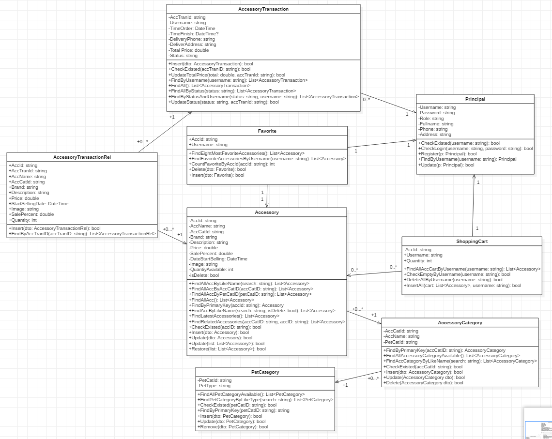

**ENTITY RELATIONSHIP DIAGRAM (ERD)  
  
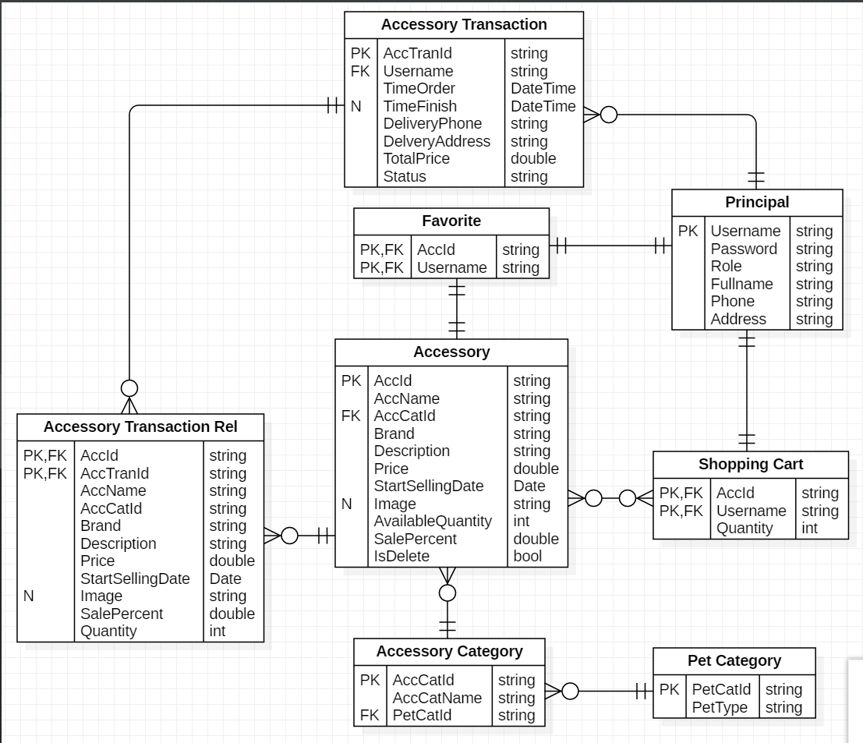  
  
  
  
TABLE DESIGN**

1. **Accessory:**

|  |  |  |  |  |  |
| --- | --- | --- | --- | --- | --- |
| **No** | **Column Name** | **Data Type** | **Size** | **Check** | **Description** |
| 1 | ⚿ AccId | nvarchar | 15 | Not Null | Accessory ID |
| 2 | AccName | nvarchar | 50 | Not Null | Accessory name |
| 3 | AccCatId | nvarchar | 15 | Not Null | Accessory’s category ID |
| 4 | Brand | nvarchar | 50 | Not Null | Accessory brand |
| 5 | Description | nvarchar | 500 | Not Null | Accessory description |
| 6 | Price | float |  | Not Null | Accessory price |
| 7 | StartSellingDate | date |  | Not Null | The date which accessory starts selling |
| 8 | Image | nvarchar | 500 | Null | Accessory’s image |
| 9 | AvailableQuantity | int |  | Not Null | Quantity of accessory available |
| 10 | SalePercent | float |  | Not Null | Sale discount on accessory |
| 11 | IsDelete | bit |  | Not Null | Check if accessory is deleted or not |

1. **Accessory Category:**

|  |  |  |  |  |  |
| --- | --- | --- | --- | --- | --- |
| **No** | **Column Name** | **Data Type** | **Size** | **Check** | **Description** |
| 1 | ⚿ AccCatId | nvarchar | 15 | Not Null | Accessory’s category ID |
| 2 | AccCatName | nvarchar | 50 | Not Null | Accessory’s category name |
| 3 | PetCatId | nvarchar | 15 | Not Null | Pet category ID |

1. **Pet Category:**

|  |  |  |  |  |  |
| --- | --- | --- | --- | --- | --- |
| **No** | **Column Name** | **Data Type** | **Size** | **Check** | **Description** |
| 1 | ⚿ PetCatId | nvarchar | 15 | Not Null | Pet category ID |
| 2 | PetType | nvarchar | 50 | Not Null | Pet type |

1. **Favorite:**

|  |  |  |  |  |  |
| --- | --- | --- | --- | --- | --- |
| **No** | **Column Name** | **Data Type** | **Size** | **Check** | **Description** |
| 1 | ⚿ AccId | nvarchar | 15 | Not Null | Accessory ID |
| 2 | ⚿Username | nvarchar | 50 | Not Null | Username |

1. **Shopping Cart:**

|  |  |  |  |  |  |
| --- | --- | --- | --- | --- | --- |
| **No** | **Column Name** | **Data Type** | **Size** | **Check** | **Description** |
| 1 | ⚿ AccId | nvarchar | 15 | Not Null | Accessory ID |
| 2 | ⚿Username | nvarchar | 50 | Not Null | Username |
| 3 | Quantity | int |  | Not Null | Quantity |

1. **Principal:**

|  |  |  |  |  |  |
| --- | --- | --- | --- | --- | --- |
| **No** | **Column Name** | **Data Type** | **Size** | **Check** | **Description** |
| 1 | ⚿ Username | nvarchar | 50 | Not Null | Username |
| 2 | Password | nvarchar | 50 | Not Null | Password |
| 3 | Role | nvarchar | 50 | Not Null | Role |
| 4 | Fullname | nvarchar | 50 | Not Null | Full name |
| 5 | Phone | nvarchar | 50 | Not Null | Phone |
| 6 | Address | nvarchar | 500 | Not Null | Address |

**7. Accessory Transaction:**

|  |  |  |  |  |  |
| --- | --- | --- | --- | --- | --- |
| **No** | **Column Name** | **Data Type** | **Size** | **Check** | **Description** |
| 1 | ⚿ AccTranID | nvarchar | 15 | Not Null | Accessory transaction ID |
| 2 | Username | nvarchar | 50 | Not Null | Username |
| 3 | TimeOrder | DateTime |  | Not Null | Time order transaction |
| 4 | TimeFinish | DateTime |  | Null | Time finish transaction |
| 5 | DeliveryPhone | nvarchar | 50 | Not Null | Phone number for delivery |
| 6 | DeliveryAddress | nvarchar | 500 | Not Null | Address for delivery |
| 7 | TotalPrice | float |  | Not Null | Total price of transaction |
| 8 | Status | nvarchar | 50 | Not Null | Status of transaction |

**8. Accessory Transaction Rel:**

|  |  |  |  |  |  |
| --- | --- | --- | --- | --- | --- |
| **No** | **Column Name** | **Data Type** | **Size** | **Check** | **Description** |
| 1 | ⚿ AccId | nvarchar | 15 | Not Null | Accessory ID |
| 2 | ⚿ AccTranId | nvarchar | 15 | Not Null | Accessory transaction Id |
| 3 | AccName | nvarchar | 50 | Not Null | Accessory name |
| 4 | AccCatId | nvarchar | 15 | Not Null | Accessory category ID |
| 5 | Brand | nvarchar | 50 | Not Null | Brand |
| 6 | Description | nvarchar | 500 | Not Null | Description |
| 7 | Price | float |  | Not Null | Price |
| 8 | StartSellingDate | Date |  | Not Null | The date when accessory started selling |
| 9 | Image | nvarchar | 500 | Null | Image of accessory |
| 10 | SalePercent | float |  | Not Null | Sale percent on accessory |
| 11 | Quantity | int |  | Not Null | Number of accessories bought |

**Note**

⚿ Primary key

**_** (underline): Foreign key

**TABLE RELATIONSHIP DIAGRAM**

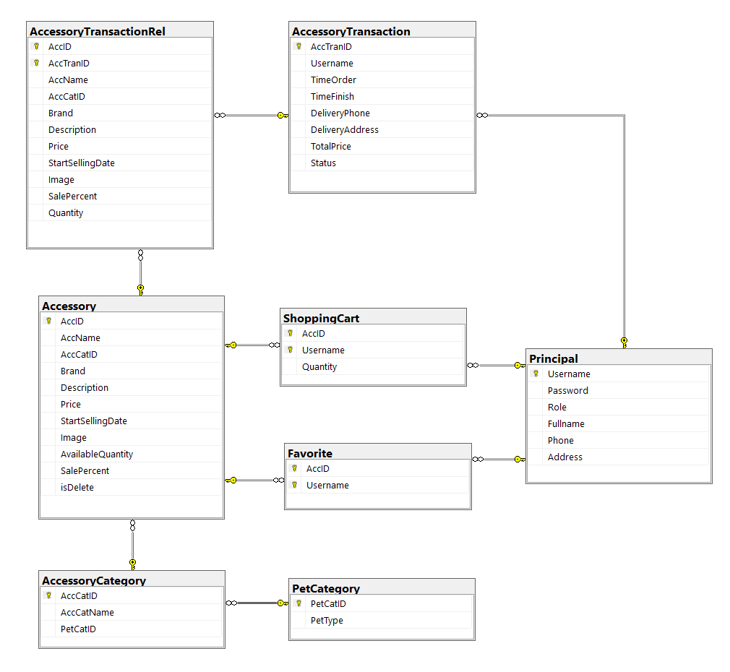

**REVIEW 3**

**INTERFACE DESIGN**

**A.USER:**

1. **Home Page:**

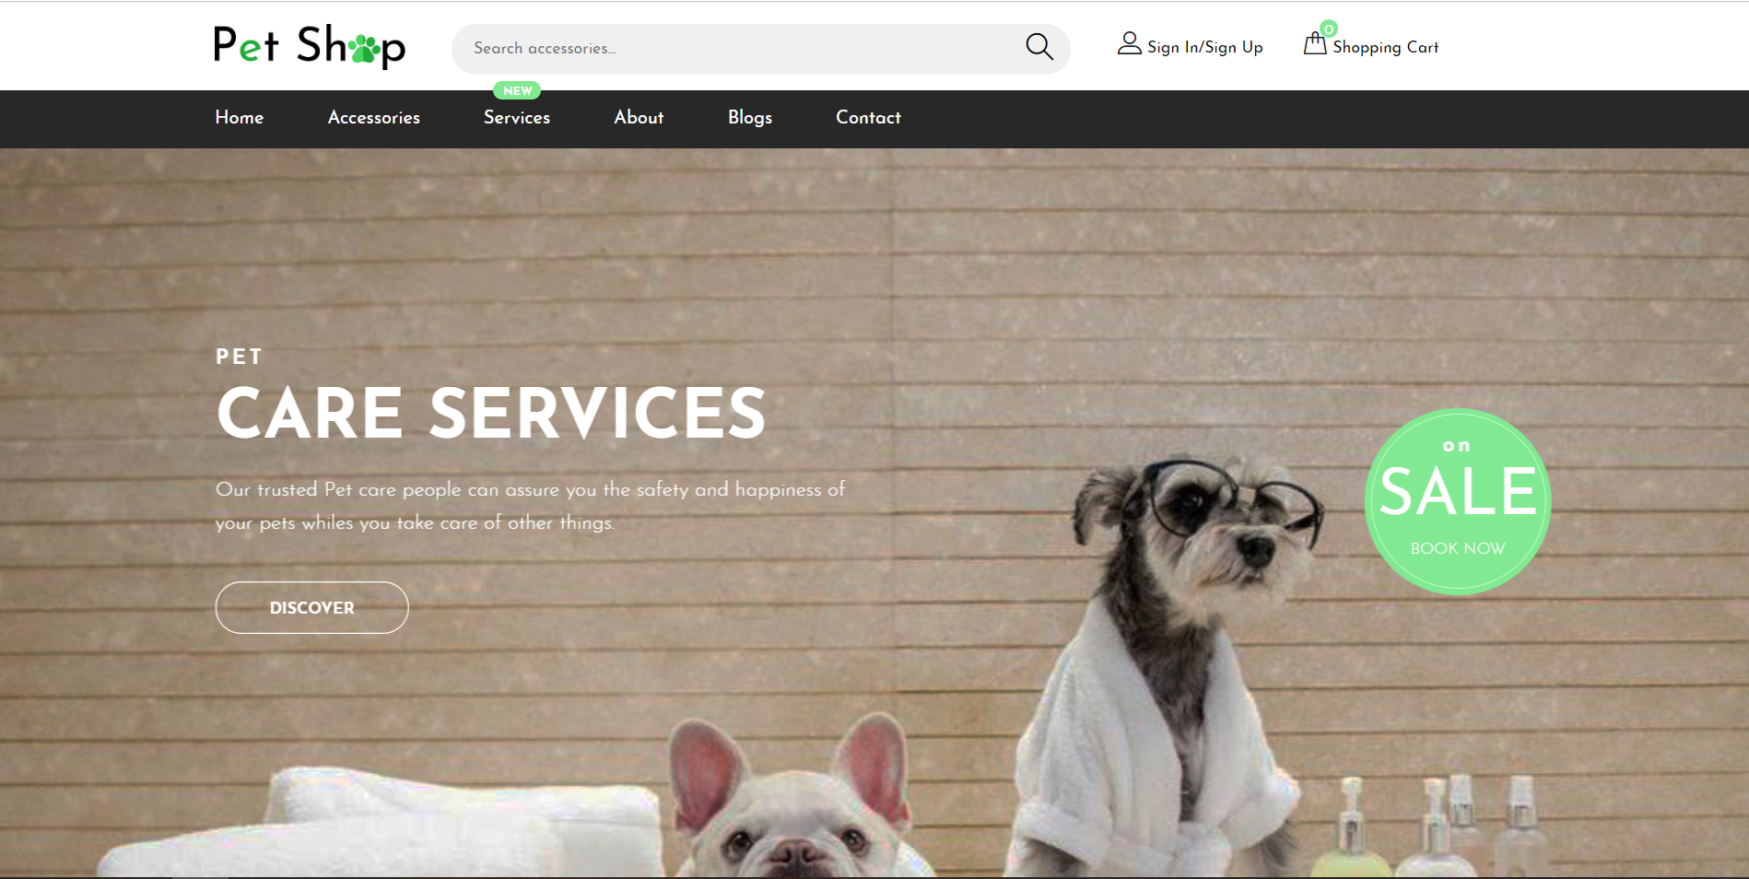

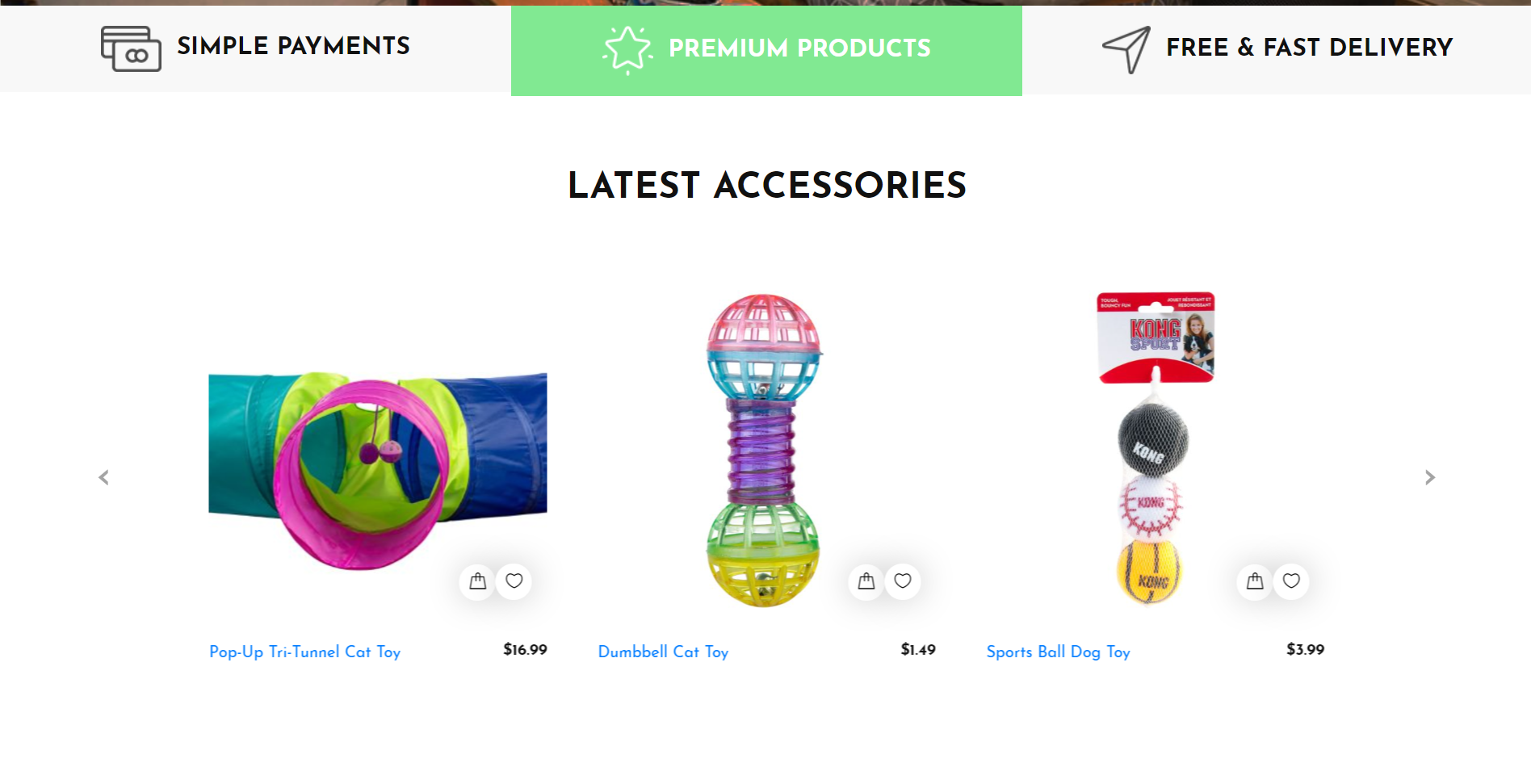

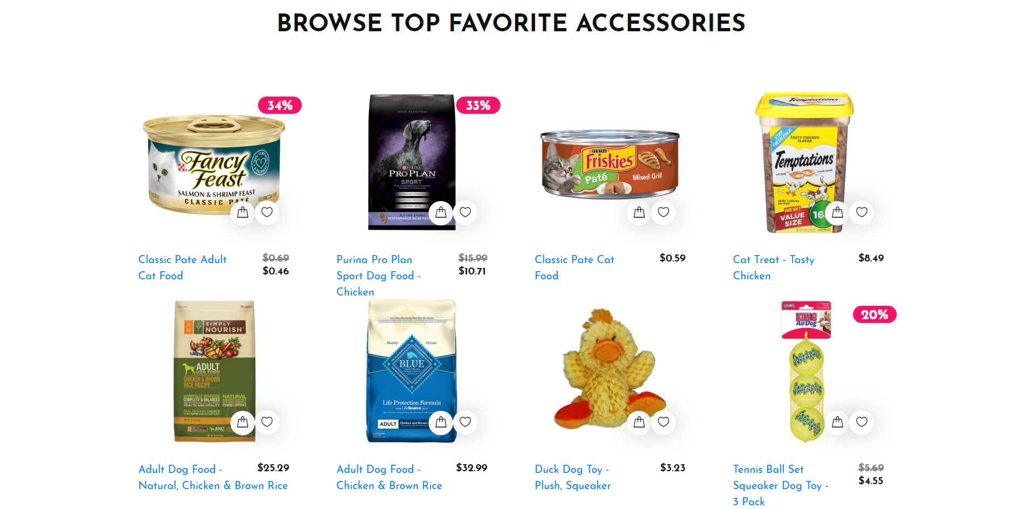

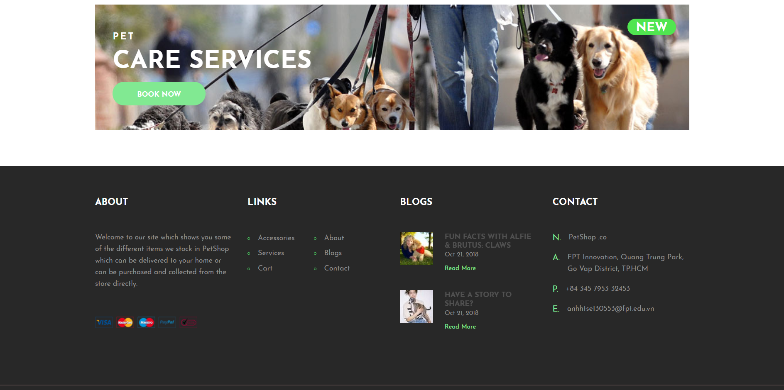

1. **Login:**

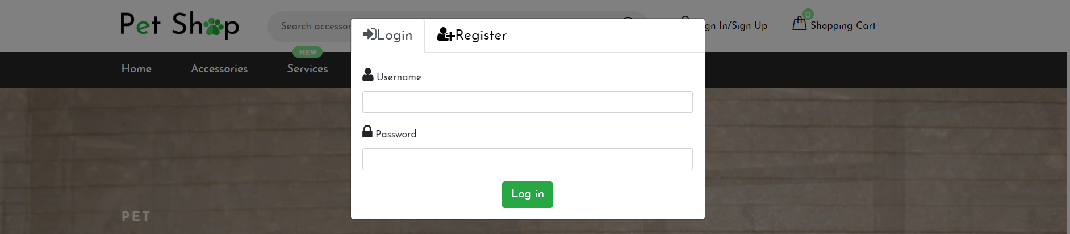

|  |  |  |  |  |  |
| --- | --- | --- | --- | --- | --- |
| **Name** | **Type** | **Event** | **Validation** | **Description** | **Status** |
| Username | TextBox |  | String, not null | Input User’s username |  |
| Password | TextBox |  | String, not null, | Input User’s password |  |
| Login | Button |  | Click | Login |  |
| Register | Tab Button |  | Click | Navigate to Register modal |  |

1. **Register:**

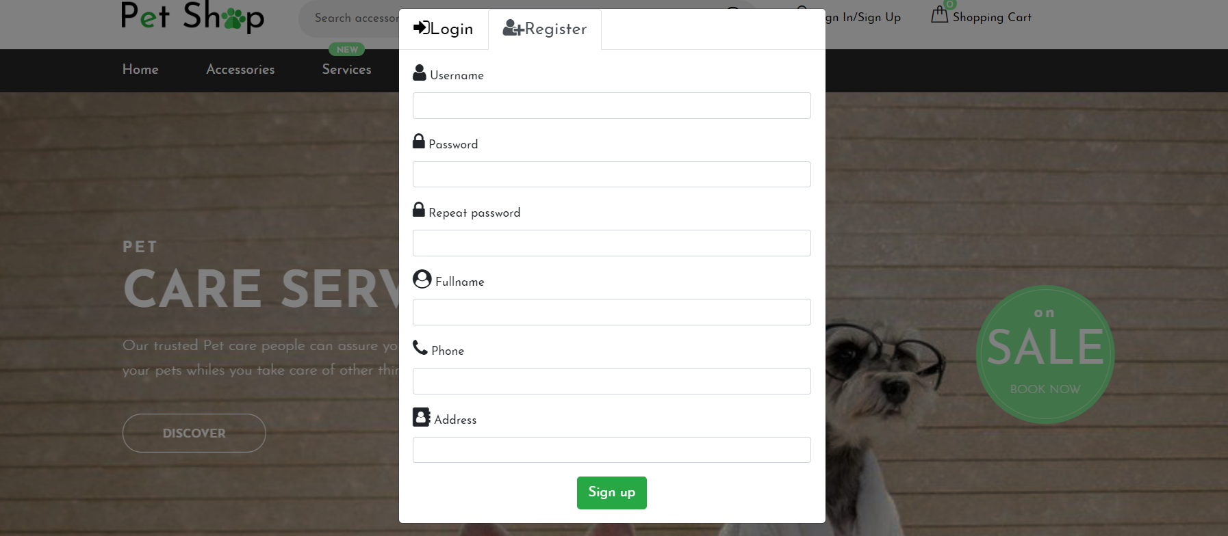

|  |  |  |  |  |  |
| --- | --- | --- | --- | --- | --- |
| **Name** | **Type** | **Event** | **Validation** | **Description** | **Status** |
| UserName | TextBox |  | String, not null,  valid username | Input User’s UserName |  |
| Password | TextBox |  | String, not null, valid password | Input User’s password |  |
| Repeat Password | TextBox |  | String, not null | User confirms his password |  |
| Fullname | TextBox |  | String, not null | Input User’s fullname |  |
| Address | TextBox |  | String, not null | Input User’s address |  |
| Phone Number | TextBox |  | String, not null, valid phone number | Input User’s phone number |  |
| Register | Button |  | Click | Register |  |
| Login | Tab Button |  | Click | Navigate to Login Tab |  |

1. **Accessories Page:**

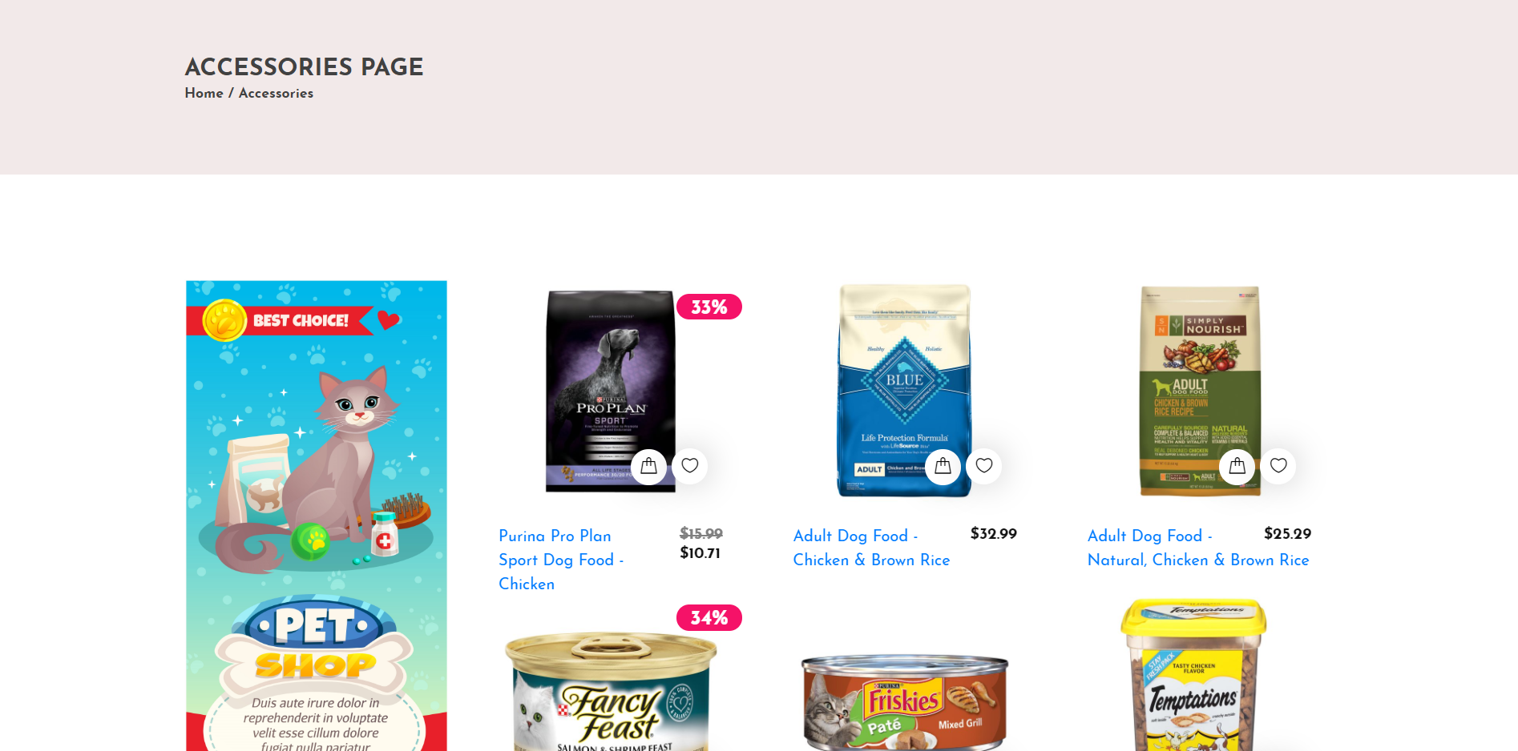

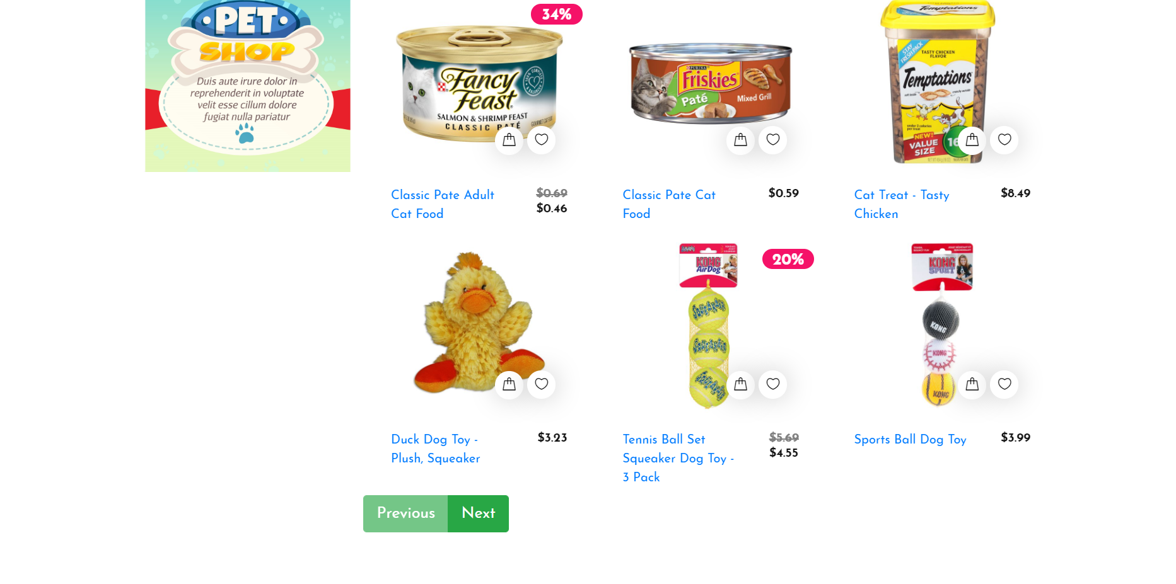

1. **View User’s Information:**

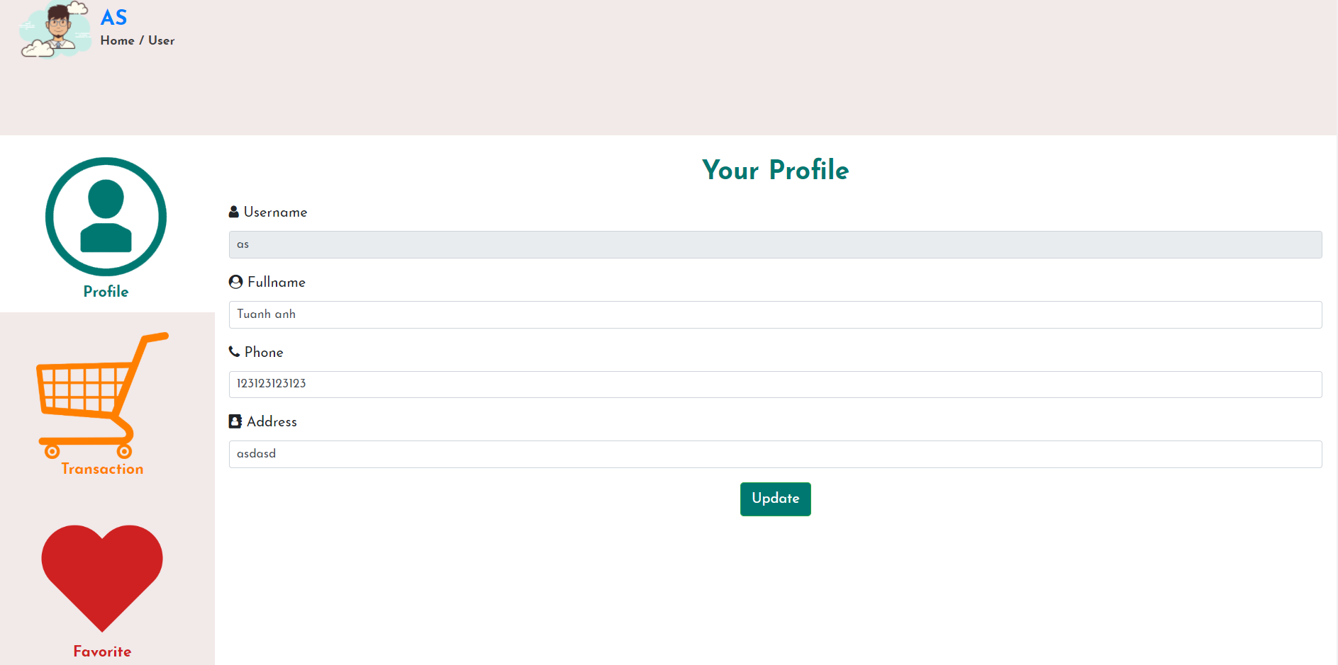

|  |  |  |  |  |  |
| --- | --- | --- | --- | --- | --- |
| **Name** | **Type** | **Event** | **Validation** | **Description** | **Status** |
| txtUsername | TextBox |  | String, not null, readonly | Show Username |  |
| txtFullname | TextBox |  | String, not null, readonly | Show User’s fullname |  |
| txtAddress | TextBox |  | String, not null, readonly | Show user’s address |  |
| txtPhoneNumber | TextBox |  | String, not null,, readonly | Show user’s phone number |  |
| Update | Button |  | Click | Update User’s Information |  |
| Transaction | LinkButton |  | Click | Navigate to Transaction Tab |  |
| Favorite | LinkButton |  | Click | Navigate to Favorite Tab |  |

1. **Show User’s Transaction:**

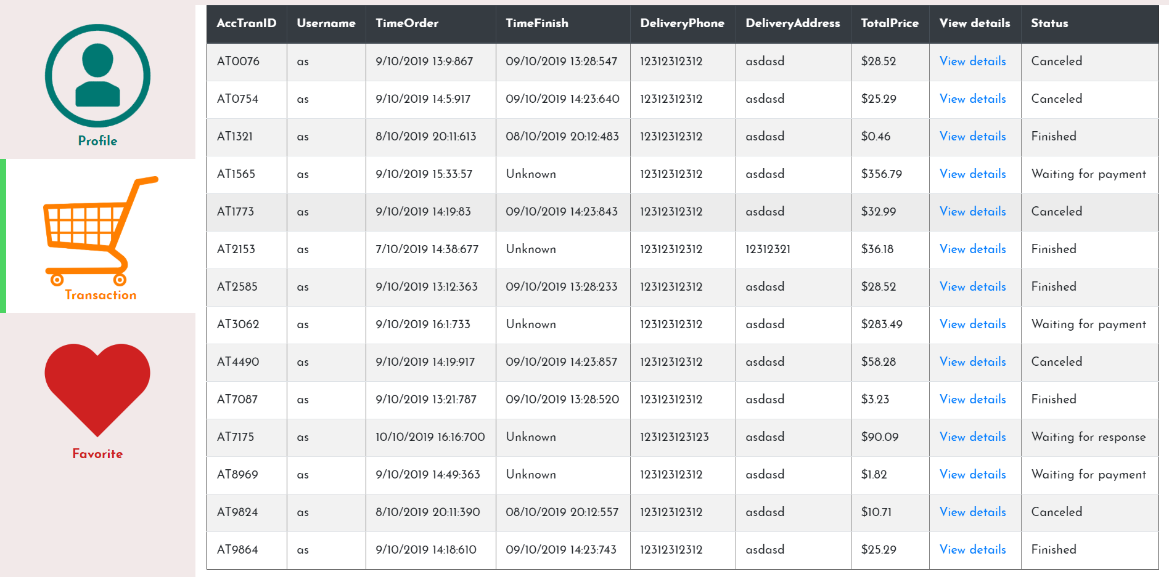

|  |  |  |  |  |  |
| --- | --- | --- | --- | --- | --- |
| **Name** | **Type** | **Event** | **Validation** | **Description** | **Status** |
| View details | LinkButton |  | Click | View details all accessories in desired transaction |  |
| table | Table |  |  | Show user’s transaction |  |

1. **Favorite list:**

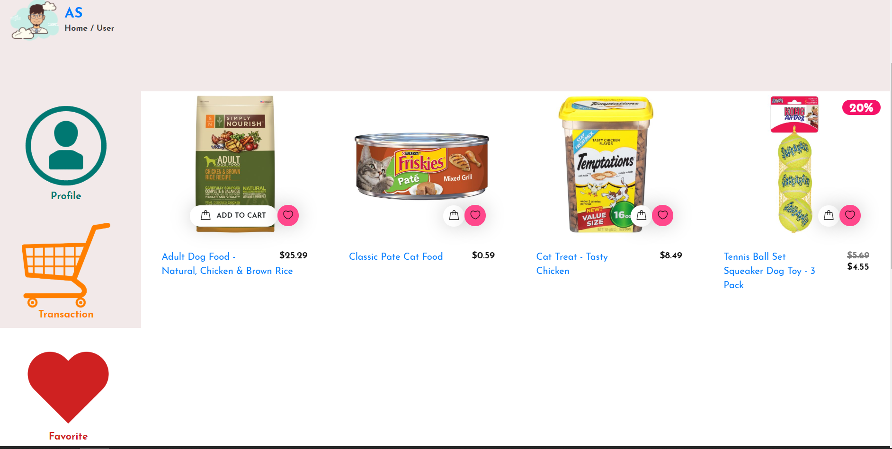

|  |  |  |  |  |  |
| --- | --- | --- | --- | --- | --- |
| **Name** | **Type** | **Event** | **Validation** | **Description** | **Status** |
| Container | div |  |  | Show favorite list of accessories |  |

1. **Product page:**

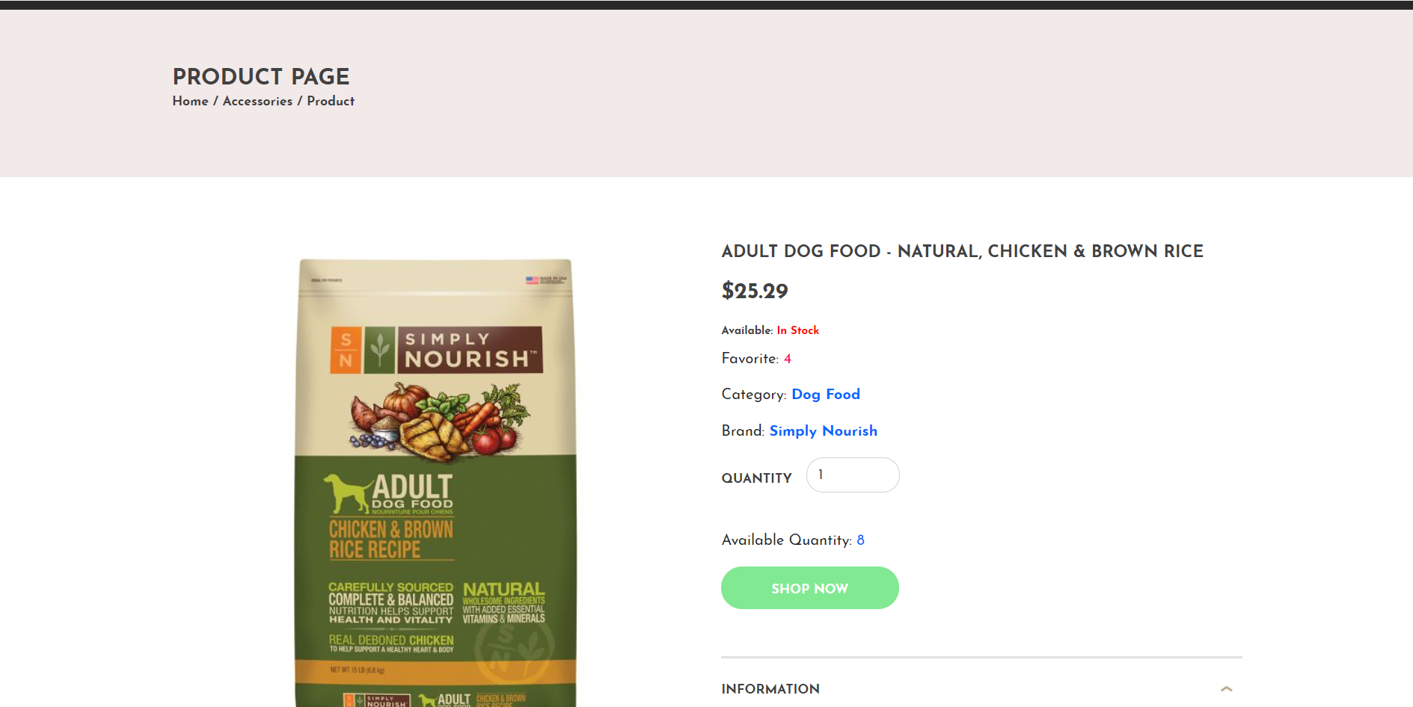

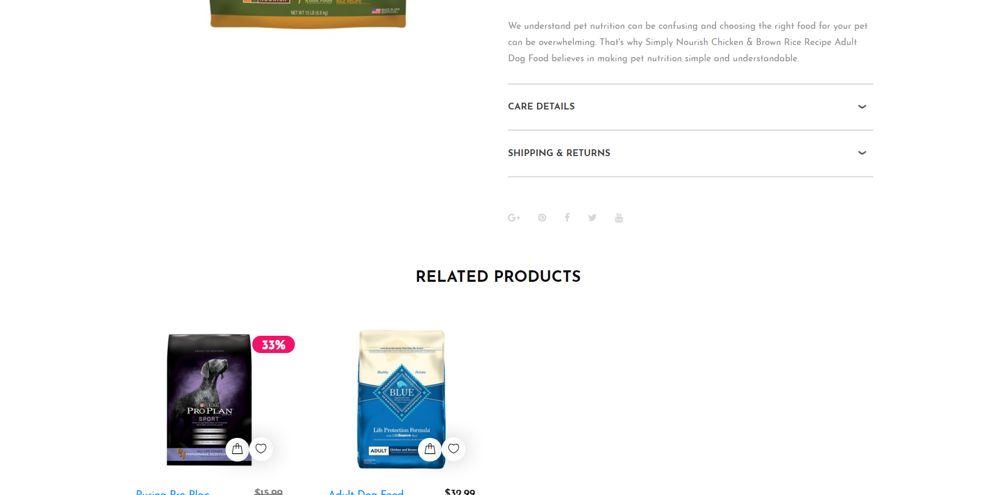

|  |  |  |  |  |  |
| --- | --- | --- | --- | --- | --- |
| **Name** | **Type** | **Event** | **Validation** | **Description** | **Status** |
| txtQuantity | Up-Down Input |  | Number, not null, greater than 0 and not greater than product’s maximum quantity | Input quantity of the product |  |
| Shop Now | Button |  | Click | Add product to cart |  |
| Description | Button |  | Click | Switch to Description tab |  |
| Care Details | Button |  | Click | Switch to Care Detaild tab |  |
| Shipping & Return | Button |  | Click | Switch to Shipping & Return tab |  |

1. **Cart page:**

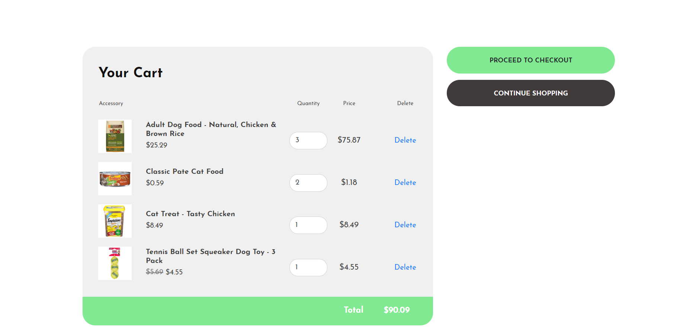

|  |  |  |  |  |  |
| --- | --- | --- | --- | --- | --- |
| **Name** | **Type** | **Event** | **Validation** | **Description** | **Status** |
| txtQuantity | TextBox |  | Number, not null, greater than 0 and not greater than product’s maximum quantity | Input quantity of the product |  |
| Delete | LinkButton |  |  | Remove the product from cart |  |
| Continue Shopping | Button |  | Click | Navigate to Accessory page |  |
| Proceed to checkout | Button |  | Click | Navigate to checkout cart page |  |

1. **Checkout cart:**

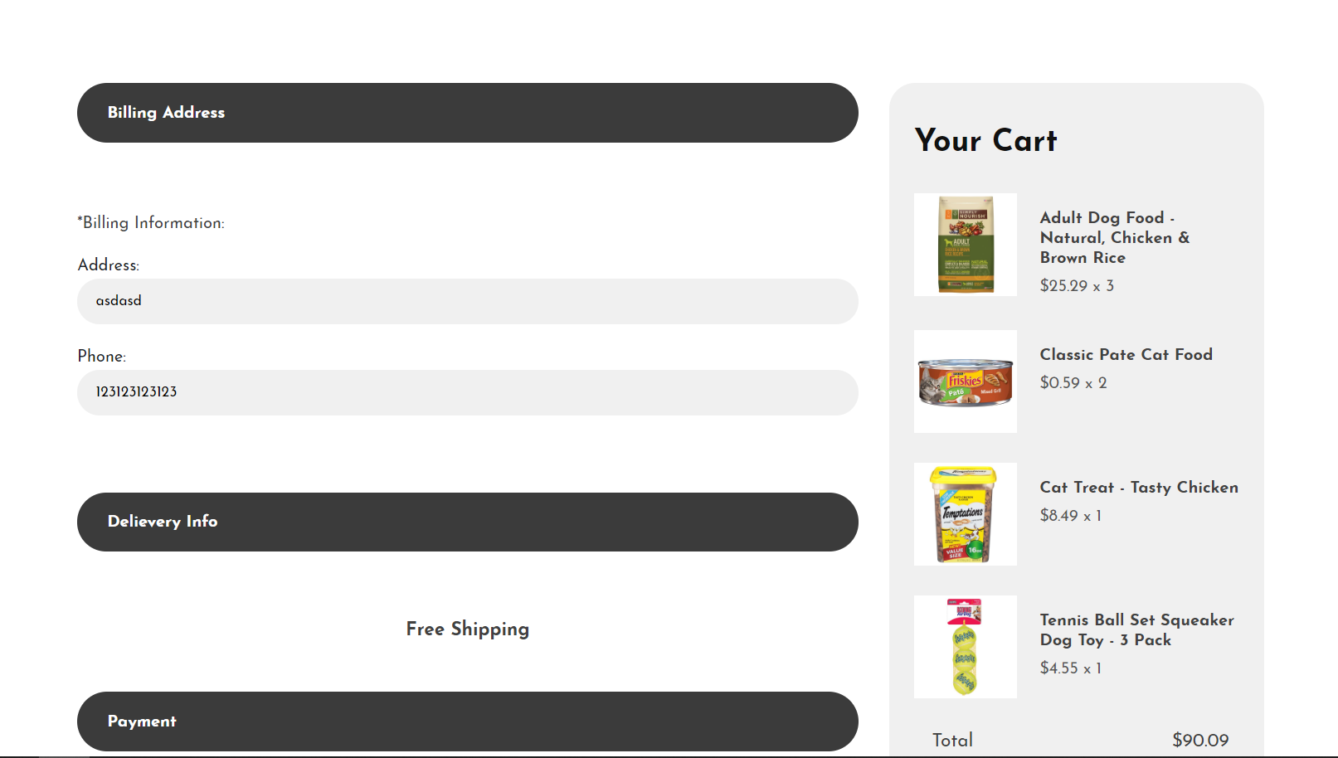

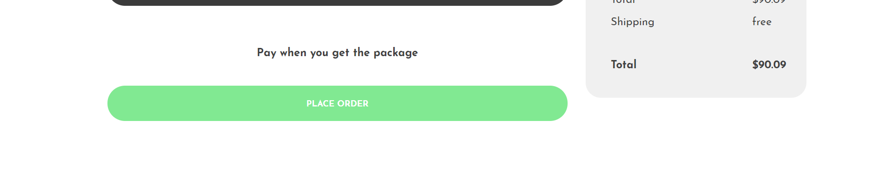

|  |  |  |  |  |  |
| --- | --- | --- | --- | --- | --- |
| **Name** | **Type** | **Event** | **Validation** | **Description** | **Status** |
| txtAddress | TextBox |  | String, not null | Show user’s address |  |
| txtPhoneNumber | TextBox |  | String, not null | Show user’s phone number |  |
| Place Order | Button |  | Click | Create a transaction, navigate to User Page |  |

**B. ADMIN:**

1. **Accessories Manager:**

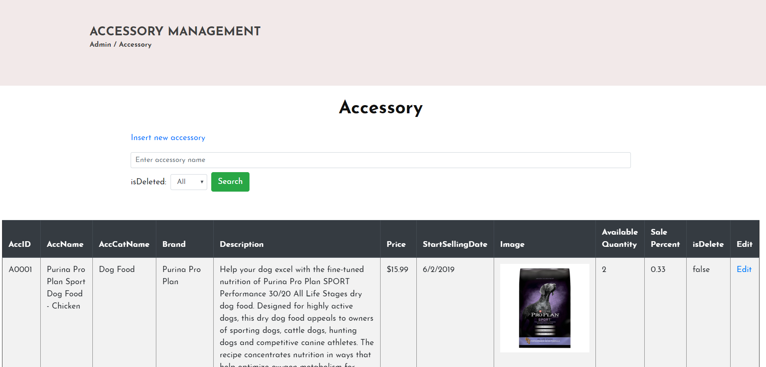

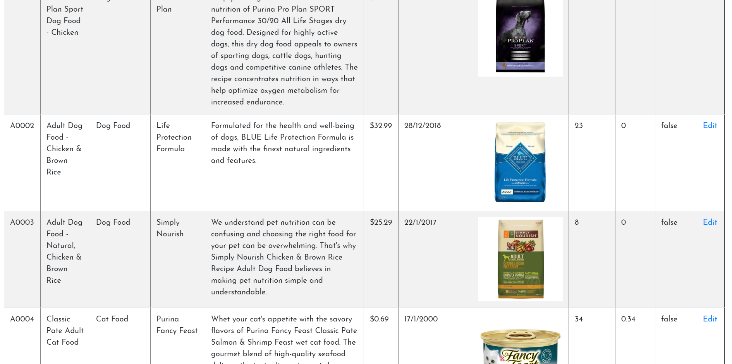

|  |  |  |  |  |  |
| --- | --- | --- | --- | --- | --- |
| **Name** | **Type** | **Event** | **Validation** | **Description** | **Status** |
| txtSearch | TextBox |  | String, | Input search keywords |  |
| IsDelete | Combo Box |  | String, Not null | Choose status of being removed or not |  |
| Search | Button |  | Click | Search accessories by name or IsDelete |  |
| Edit | LinkButton |  | Click | Navigate to Edit accessory Tab |  |
| table | Table |  |  | Show accessories’ information |  |

1. **Add new accessory:**

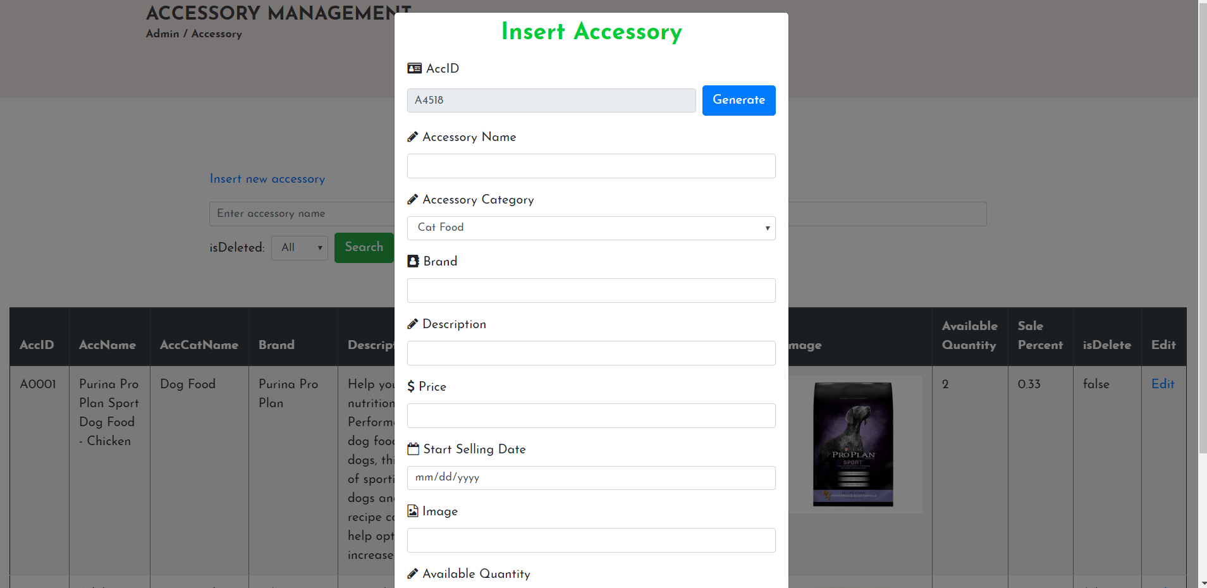

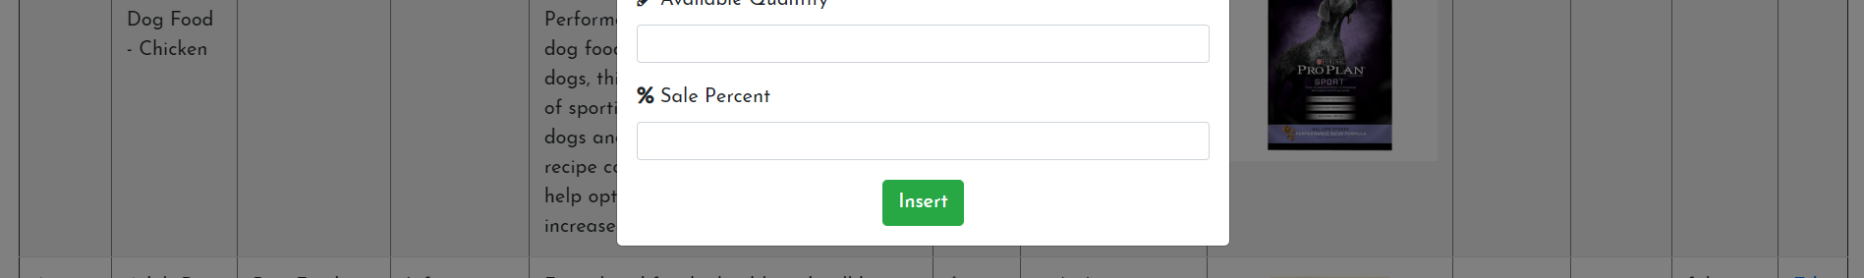

|  |  |  |  |  |  |
| --- | --- | --- | --- | --- | --- |
| **Name** | **Type** | **Event** | **Validation** | **Description** | **Status** |
| txtAccid | TextBox |  | String, Not null, readonly | Show Accessory ID |  |
| Generate | Button |  | Click | Generate a new valid accessory ID |  |
| txtName | TextBox |  | String, Not null | Input accessory name |  |
| txtAccCatId | Dropdown List |  | String, not null | Choose accessory’s category |  |
| txtBrand | TextBox |  | String, not null | Input brand |  |
| txtDescrption | TextBox |  | String, not null | Input description |  |
| txtPrice | TextBox |  | Number, not null | Input accessory’s price |  |
| txtStartSellingDate | Date Picker |  | Date, not null | Input date which accessory starts selling |  |
| txtImage | TextBox |  | String | Input image path |  |
| txtAvailableQuantity | TextBox |  | Number, not null | Input available quantity |  |
| txtSalePercent | TextBox |  | String, not null | Input sale percent |  |
| Insert | Button |  | Click | Insert new accessory |  |

1. **Update accessory:**

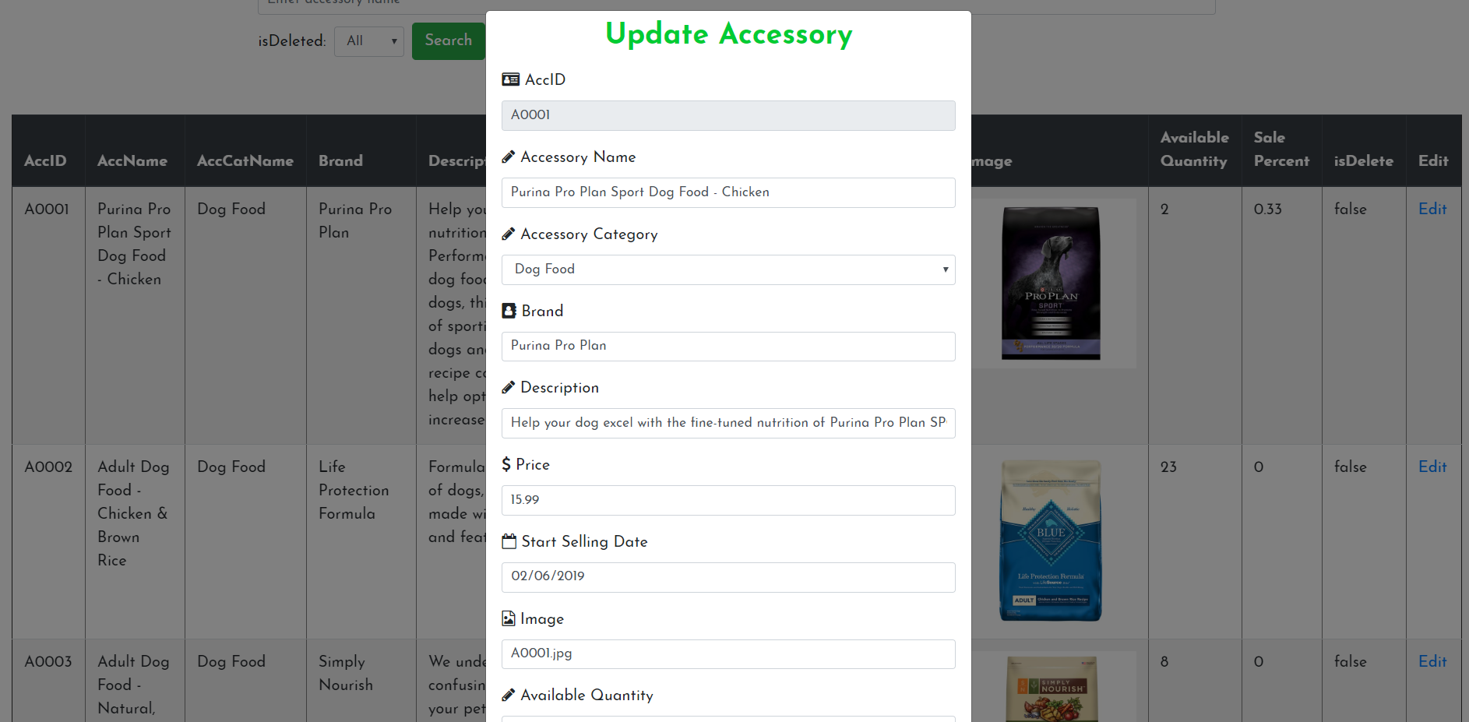

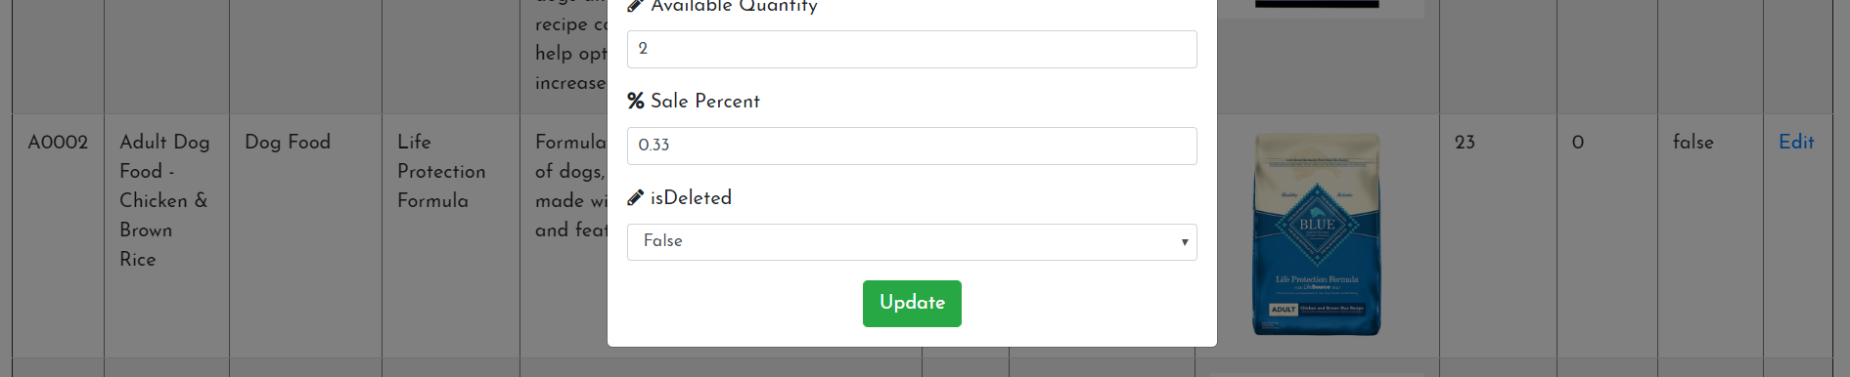

|  |  |  |  |  |  |
| --- | --- | --- | --- | --- | --- |
| **Name** | **Type** | **Event** | **Validation** | **Description** | **Status** |
| txtAccid | TextBox |  | String, Not null, readonly | Show Accessory ID |  |
| txtName | TextBox |  | String, Not null | Input accessory name |  |
| txtAccCatId | Dropdown List |  | String, not null | Choose accessory’s category |  |
| txtBrand | TextBox |  | String, not null | Input brand |  |
| txtDescrption | TextBox |  | String, not null | Input description |  |
| txtPrice | TextBox |  | Number, not null | Input accessory’s price |  |
| txtStartSellingDate | Date Picker |  | Date, not null | Input date which accessory starts selling |  |
| txtImage | TextBox |  | String | Input image path |  |
| txtAvailableQuantity | TextBox |  | Number, not null | Input available quantity |  |
| txtSalePercent | TextBox |  | String, not null | Input sale percent |  |
| Update | Button |  | Click | Update accessory |  |

1. **Category Manager:**

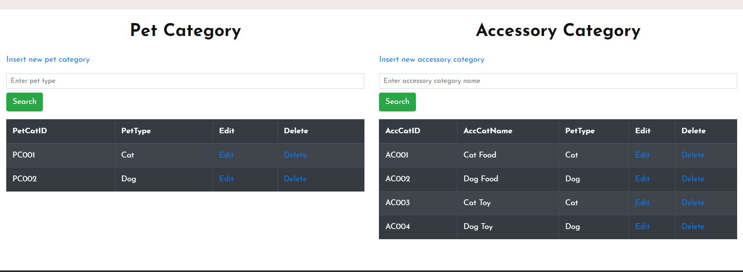

|  |  |  |  |  |  |
| --- | --- | --- | --- | --- | --- |
| **Name** | **Type** | **Event** | **Validation** | **Description** | **Status** |
| Insert | Link Button |  | Click | Navigate to Insert Category modal |  |
| txtSearch | TextBox |  | String, Not null | Input search keywords |  |
| Search | Button |  | Click | Search categories by name |  |
| Edit | LinkButton |  | Click | Navigate to Edit category Modal |  |
| Delete | LinkButton |  | Click | Delete Category |  |
| table | Table |  |  | Show categories’s information |  |

1. **Add Pet Category:**

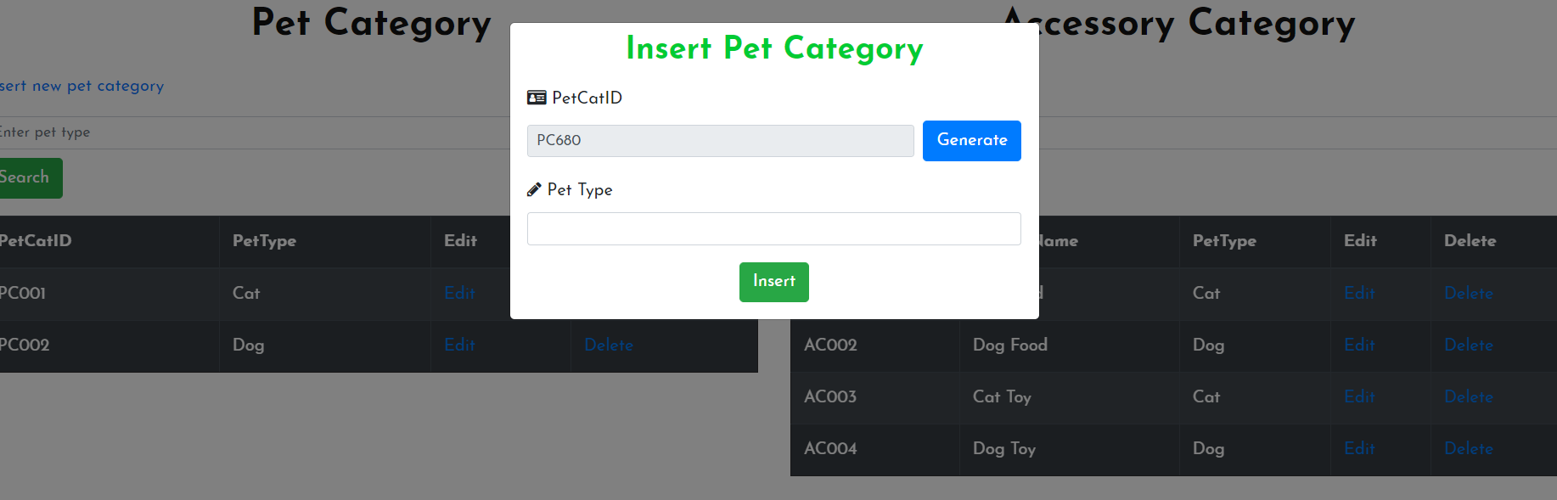

|  |  |  |  |  |  |
| --- | --- | --- | --- | --- | --- |
| **Name** | **Type** | **Event** | **Validation** | **Description** | **Status** |
| txtPetCatId | TextBox |  | String, not null, readonly | Show pet category ID |  |
| Generate | Button |  | Click | Generate a new valid pet category ID |  |

|  |  |  |  |  |  |
| --- | --- | --- | --- | --- | --- |
| txtPetType | TextBox |  | String, not null | Input pet Category name |  |

|  |  |  |  |  |  |
| --- | --- | --- | --- | --- | --- |
| Insert | LinkButton |  | Click | Add pet category |  |

1. **Edit Pet Category:**

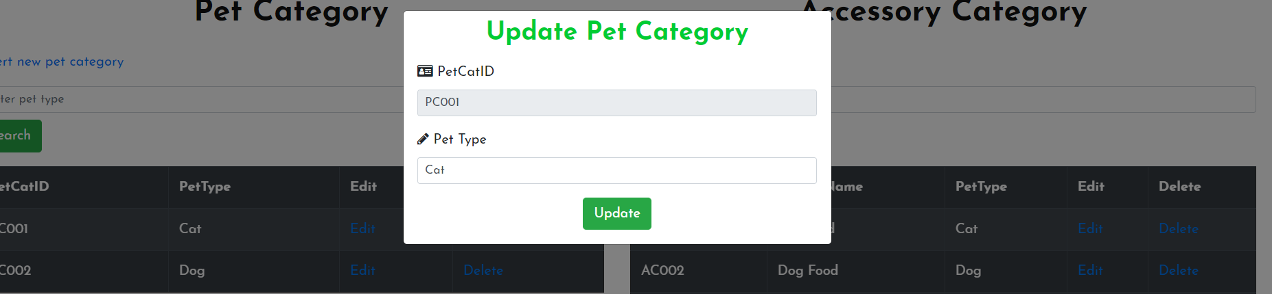

|  |  |  |  |  |  |
| --- | --- | --- | --- | --- | --- |
| **Name** | **Type** | **Event** | **Validation** | **Description** | **Status** |
| txtPetCatID | TextBox |  | String, not null, readonly | Show pet Category id |  |
| txtPetType | TextBox |  | String, not null | Input pet category name |  |
| Update | LinkButton |  | Click | Update pet category |  |

1. **Add Accesory Category:**

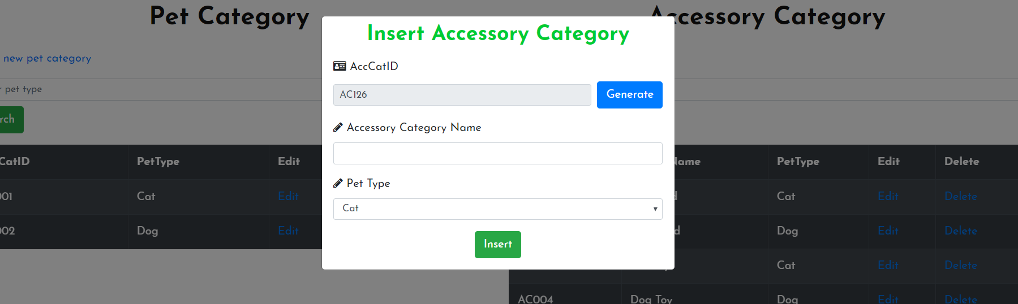

|  |  |  |  |  |  |
| --- | --- | --- | --- | --- | --- |
| **Name** | **Type** | **Event** | **Validation** | **Description** | **Status** |
| txtAccCatId | TextBox |  | String, not null, readonly | Show accessory category ID |  |
| Generate | Button |  | Click | Generate a new valid accessory category ID |  |
| txtAccCatName | TextBox |  | String, not null | Input accessory Category name |  |
| cbPetType | Combo Box |  | String, not null | Choose pet type |  |
| Insert | LinkButton |  | Click | Add accessory category |  |

1. **Edit Accessory Category:**

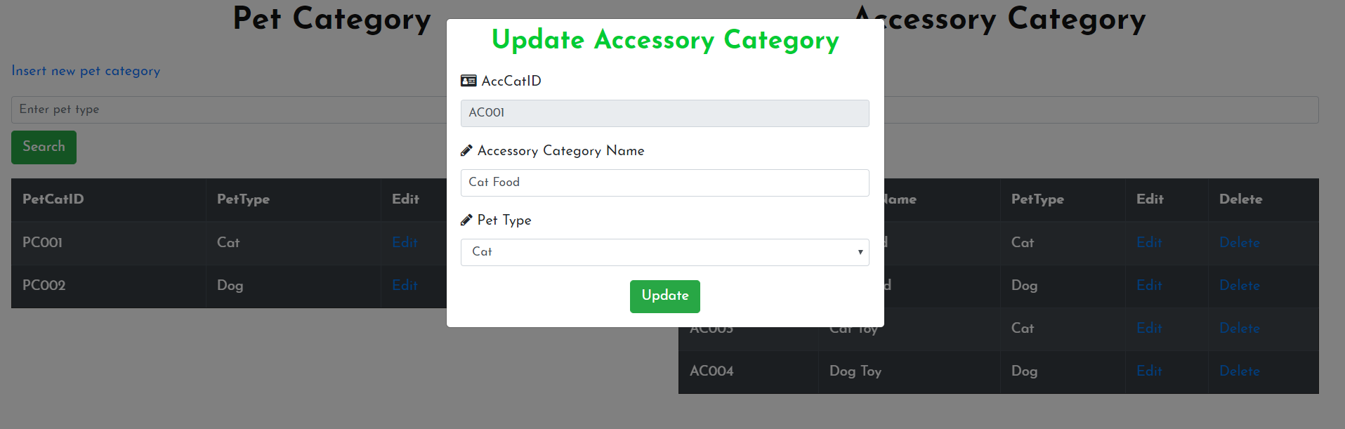

|  |  |  |  |  |  |
| --- | --- | --- | --- | --- | --- |
| **Name** | **Type** | **Event** | **Validation** | **Description** | **Status** |
| txtAccCatID | TextBox |  | String, not null, readonly | Show accessory Category id |  |
| txtAccCatName | TextBox |  | String, not null | Input accessory category name |  |
| cbPetType | ComboBox |  | String, not null | Choose pet type |  |
| Update | LinkButton |  | Click | Update accessory category |  |

1. **Transaction Manager:**

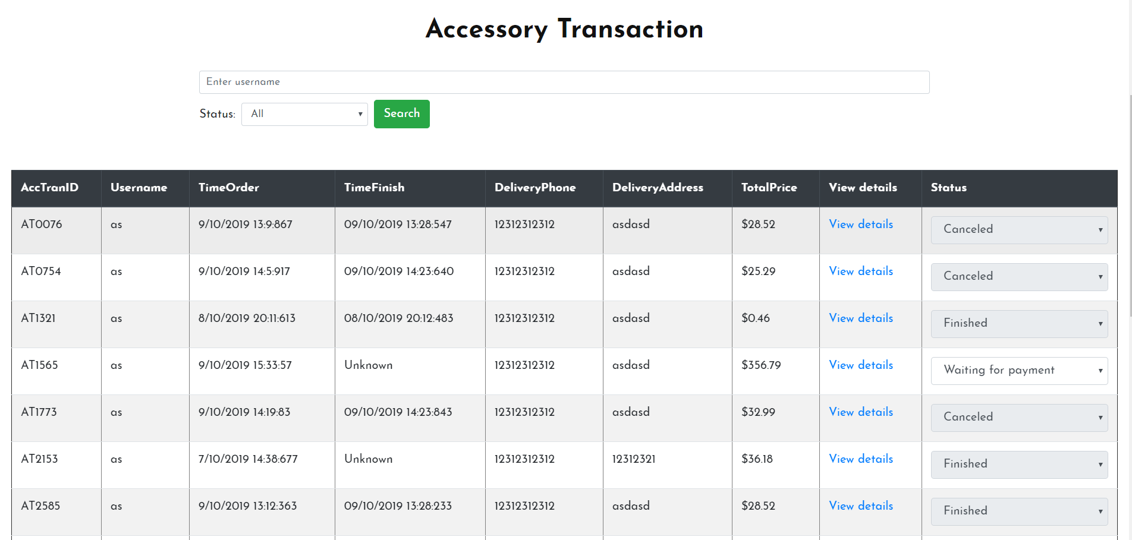

|  |  |  |  |  |  |
| --- | --- | --- | --- | --- | --- |
| **Name** | **Type** | **Event** | **Validation** | **Description** | **Status** |
| txtSearch | TextBox |  | String, Not null | Input search keywords |  |
| StatusSearch | Dropdown List |  | Choose one of the options | Choose status of transactions |  |
| Search | Button |  | Click | Search transaction by username and Status |  |
| table | Table |  |  | Show transactions’ information |  |
| ViewDetails | LinkButton |  | Click | Navigate to ViewDetails transaction modal |  |
| Status | DropDown List |  | Choose one of options | Choose status to update |  |

1. **Transaction details:**

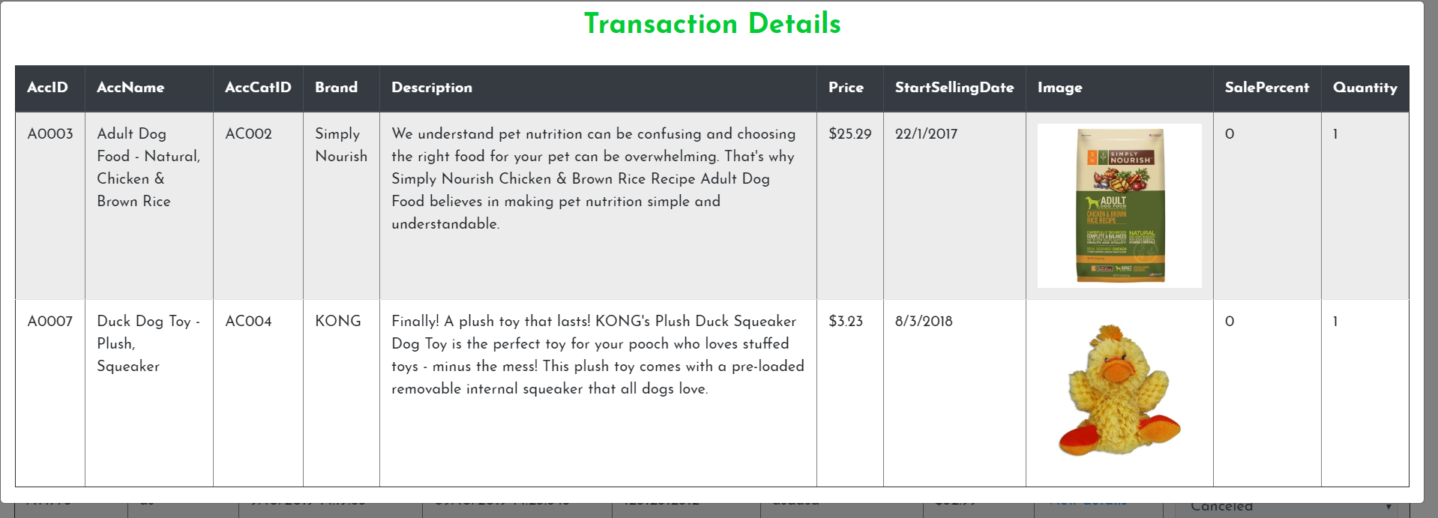

**TASK SHEET**

|  |  |  |  |  |  |  |  |  |  |  |
| --- | --- | --- | --- | --- | --- | --- | --- | --- | --- | --- |
| **Project Group CHT** | | **Project Title**  **Online Shoes Store** | | | **Date of Preparation** | | | | **Activity Plan Prepared by**  **CHT** | |
| **No** | **Task Title** | | | **Planned Start Date** | **Planned Completed Date** | | **Team Mate Names** | | **Status** | |
| **\*** **Accessories Management:** | | | | | | | | | | |
| 1 | Add accessories | | |  |  | |  | | Done | |
| 2 | Edit attributes of accessories | | |  |  | |  | | Done | |
| 3 | Delete/Restore accessories | | |  |  | |  | | Done | |
| 4 | Add accessories images | | |  |  | |  | | Done | |
| 5 | Feature accessories on the homepage | | |  |  | |  | | Done | |
| 6 | Search to easily find accessories in certain categories, name | | |  |  | |  | | Done | |
| 7 | Manage accessories with Table | | |  |  | |  | | Done | |
| **\*User Management:** | | | | | | | | | | |
| 8 | Login | | |  |  | |  | | Done | |
| 9 | Register | | |  |  | |  | | Done | |
| 10 | Logout | | |  |  | |  | | Done | |
| 11 | Update account details (address, phone number, ...) | | |  |  | |  | | Done | |
| 12 | View user details | | |  |  | |  | | Done | |
| **\*Favorite Management:** | | | | | | | | | | |
| 13 | Add favorite | |  | | |  | |  | | Done |
| 14 | Remove favorite | |  | | |  | |  | | Done |
| 15 | View favorite list | |  | | |  | |  | | Done |
| **\*Category Management:** | | | | | | | | | | |
| 16 | Create category | | |  |  | |  | | Done | |
| 17 | Edit category | | |  |  | |  | | Done | |
| 18 | Manage categories with Table | | |  |  | |  | | Done | |
| 19 | Feature categories within navigation, on Home Page, on Add accessory page | | |  |  | |  | | Done | |
| **\*Transaction Management:** | | | | | | | | | | |
| 33 | Add accessory to cart | | |  |  | |  | | Done | |
| 34 | Update accessory’s quantity in cart | | |  |  | |  | | Done | |
| 35 | Checkout cart | | |  |  | |  | | Done | |
| 36 | Update order status | | |  |  | |  | | Done | |
| 37 | View order information (order items, quantity, total price, ...) | | |  |  | |  | | Done | |
| 38 | Show list of order history | | |  |  | |  | | Done | |

|  |  |  |
| --- | --- | --- |
| **Date: Oct 11, 2019** | **Prepared by Project Group TA**  **Team Leader: Tuan Anh** | **Approved by**  **Mr. Ho Hoan Kiem** |
| **Signature** |  |  |